Calix E3-2 GPON

SMx Programming

(Remote Tech Assist)

Table of Contents

1.0 Overview 3
2.0 Effective Date 3
3.0 Related Links 3
4.0 E3-2 GPON Overview 3
5.0 Login 4
6.0 View Service 7
6.1 Using the Search window to View Subscriber 7
6.2 Searching for a Subscriber using the Subscriber Tab 8
6.3 Interface 10
7.0 Create Subscriber 12
8.0 Edit Subscriber 22
9.0 Edit Data Service 23
10.0 Pause Service 25
11.0 Resume Service 26
12.0 Deleting Service 27
12.1 Deleting the Subscriber 27
12.2 Deleting the ONT 27
13.0 Firmware 28
14.0 Troubleshooting 29
14.1 How to Verify the Subscriber’s IP Address 29
14.2 Linking an ONT 29
14.3 Reset ONT 34
14.4 Replace ONT 35
14.5 Searching VLANs 36
14.6 Verifying SHUTDOWN is set to False 37
14.7 How to Resynchronize the CLLI 39
14.8 No Authentication/No Ping 41
14.9 When the Registration ID (aka RONTA) is missing 41
14.10 Calix SMx Global SmartNID Search 48
15.0 Document Management 50

Overview

Target Audience | QF Programming | QF Facility Support
Impact/Benefit | This document provides steps for programming E3-2 GPON (Fiber) using the Axos SMx EMS (Element Management System).
Reason for Change | Added the Firmware section.

Effective Date

Effective Date | Expiration Date
12/06/21 | Until Further Notice

Related Links
Document Name
NetworkCo SMx (access thru AVD): https://ntco-smx.corp.intranet:3443/smx
Video: SMx - Correct a Missing Registration ID.webm
Video: SMx - Linking ONT to Subscriber Account.webm
Video: SMx - Missing CE-VLAN 201.webm
Reporting DSL Outages (Remote Tech Assist).docx
Visit the library to view all documents: https://centurylink.sharepoint.com/sites/NAOLibrary

E3-2 GPON Overview
E3-2 is an Intelligent PON Node that allows multiple PON technologies (GPON, XGS-PON and NG-PON2), and provides flexibility to fit various deployment configurations. E3-2 can support the same ONT card types as E7 GPON, including CASA DPU (ONT). Note: North Carolina field trial locations will be loaded into MARTENS and programmed Manually, while widescale deployments will be inventoried in O2 (Optius and ODiN) and supported by the Quantum Fiber stack, as well as programmed by OSG. Programming, troubleshooting and maintenance will be done through the SMx EMS.

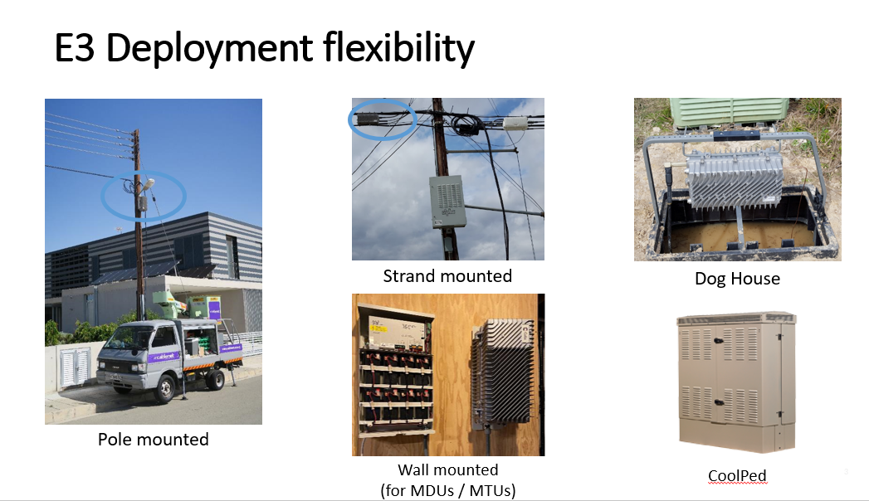

Login
The URL link to SMx has been updated. The previous URL, https://smx:3443 (also accessible via https://155.70.106.84:3443/smx/) and will no longer work at the start of the maintenance window. These URLs will be replaced by the new URL link provided in the Related Document section. This change will become effective on November 7, 2024.

Important: Users are advised to utilize the new URL link instead of the IP address, if known. This allows the Element Management Systems (EMS) Support to effectively switch the application between Omaha and Denver servers without causing disruption to end-users, particularly during maintenance or when a data center is briefly unavailable.

*Chrome is the preferred browser
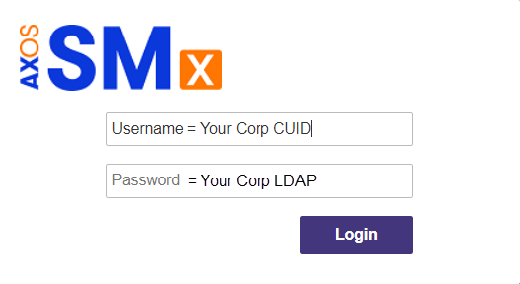
(Same Username/Password used to login to computer).

Step | Action
Input Username / Password and select Login.
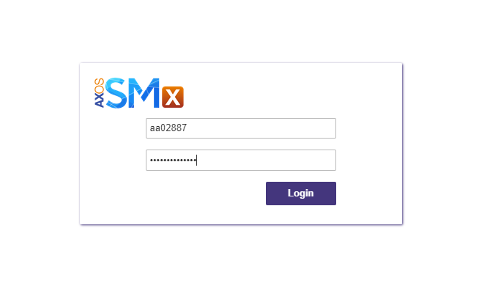

*If an alert is received that the website is not secure, select more information and proceed.
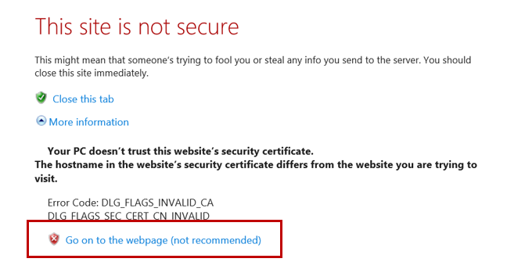
After login, the landing page will be displayed.
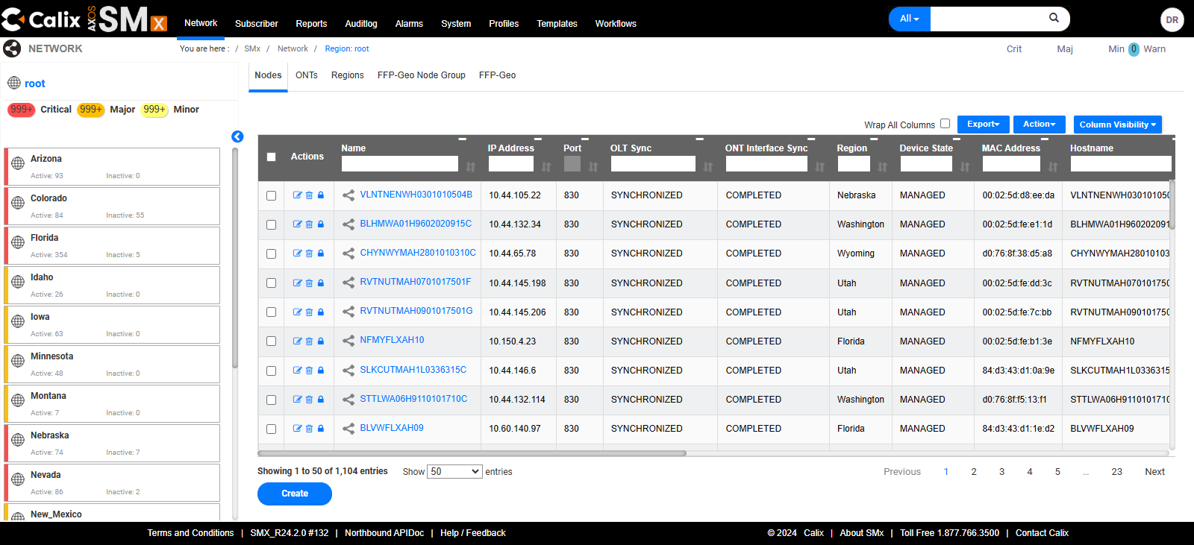
Select one’s username initials in the top right-hand corner will display a small menu including:
- Change Password
- Settings
- Log out.
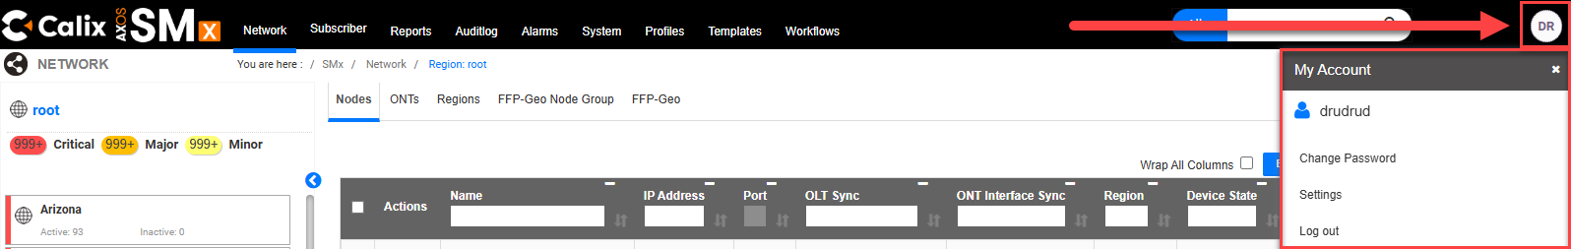

View Service

Using the Search window to View Subscriber
Step | Action
Change Filter from All to Subscriber.
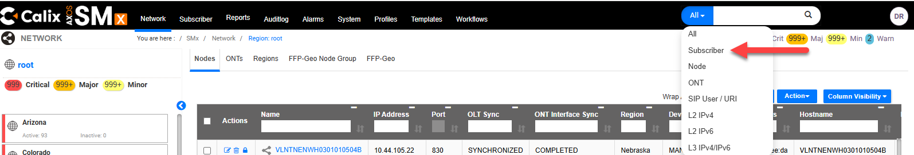
 | Enter the subscriber’s TN/DTN in the Search bar and press enter or select the looking glass.
Select the TN/DTN in blue text.
Tip: If no subscriber returned, see Create Subscriber for steps to create.
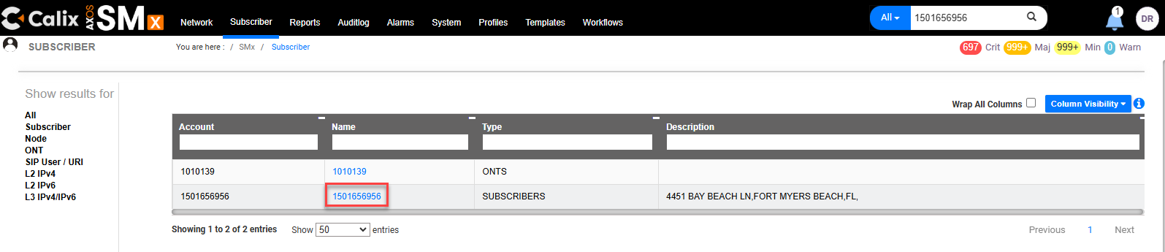
The top section of Provisioned Services will display:
- OLT Name and Port
- ONT
- Registration ID.

The Data section will display:
- Service Template (Speed)
- VLAN (VPI)
- CTAG (CVLAN / VCI).
The example below shows the customer is programmed for 1G, with SVLAN 2800 /CTAG 120.
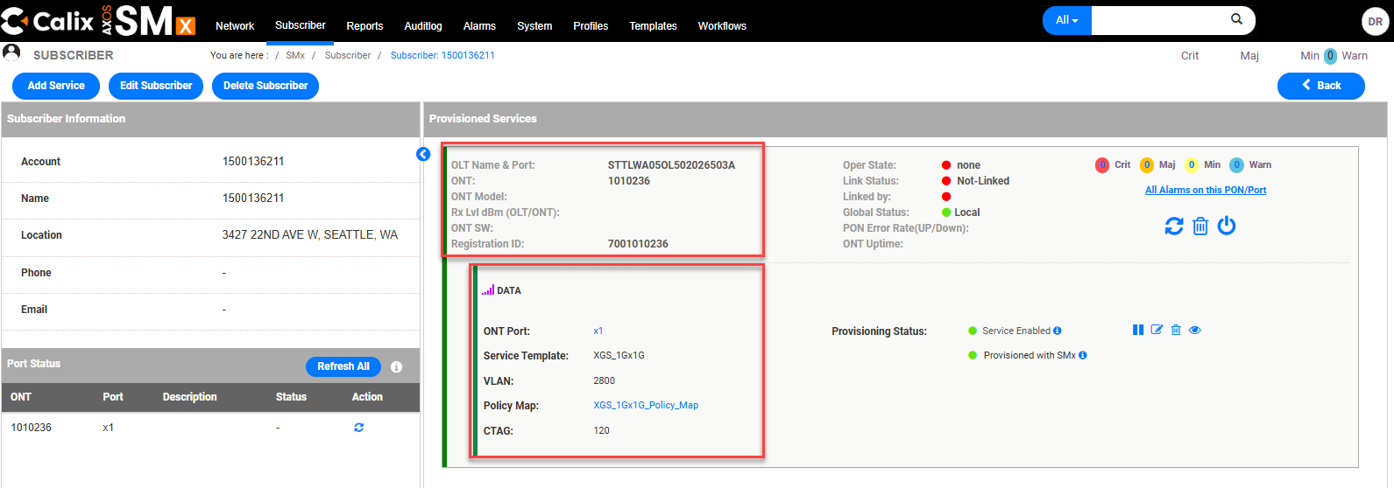

Searching for a Subscriber using the Subscriber Tab

Step | Action
Select Subscriber.
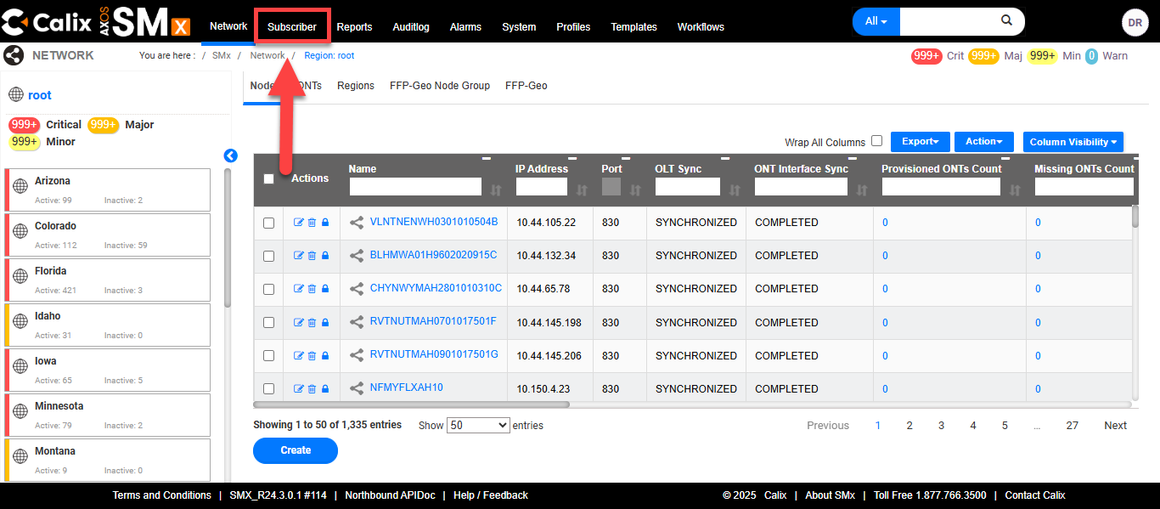
Populate the DTN in the Account field.
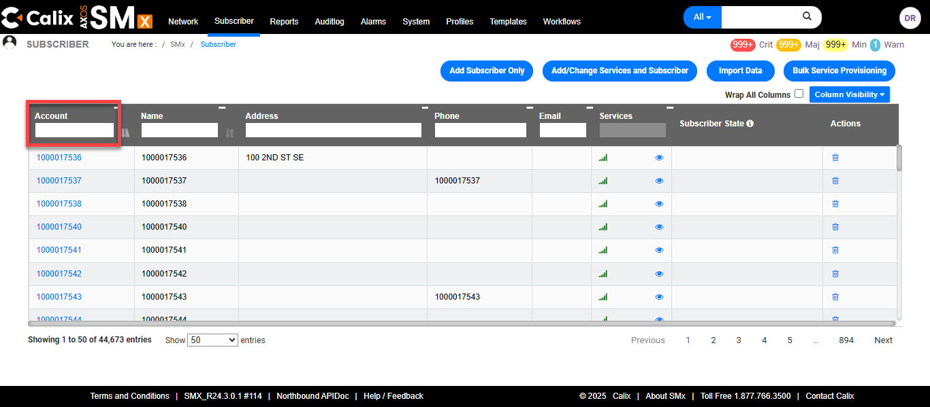
Select the hyperlink for the corresponding result.
Tip: If no subscriber returned, see Create Subscriber for steps to create.
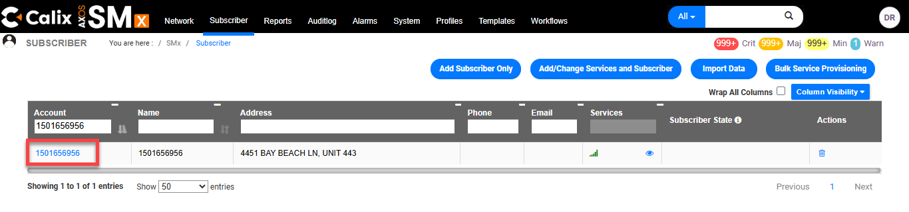
The top section of Provisioned Services will display:
- OLT Name and Port
- ONT
- Registration ID.

The Data section will display:
- Service Template (Speed)
- VLAN (VPI)
- CTAG (CVLAN / VCI).
The example below shows the customer is programmed for 1G, with SVLAN 2800 /CTAG 120.


Interface
When viewing service, if an Interface is shown, it should be corrected. This happens when the Port Description field is manually populated when it should be left blank.

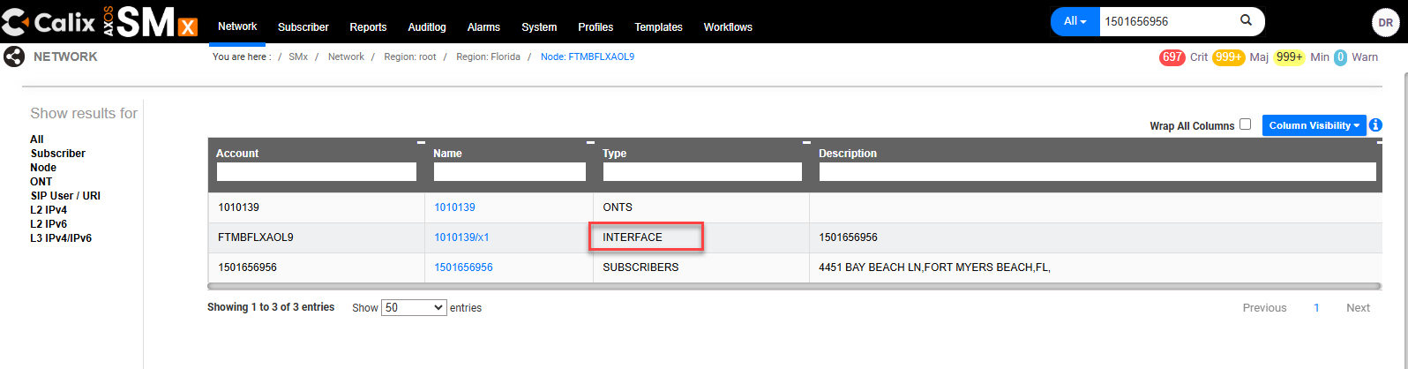

Step | Action
Select the TN/DTN link for Subscriber.
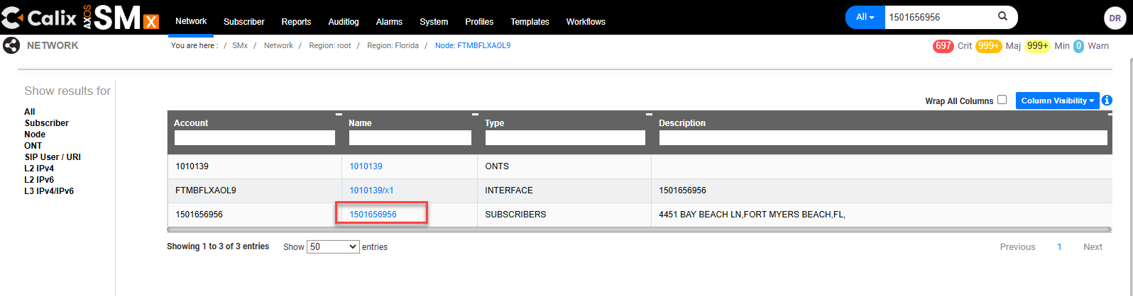
Select Edit Services .
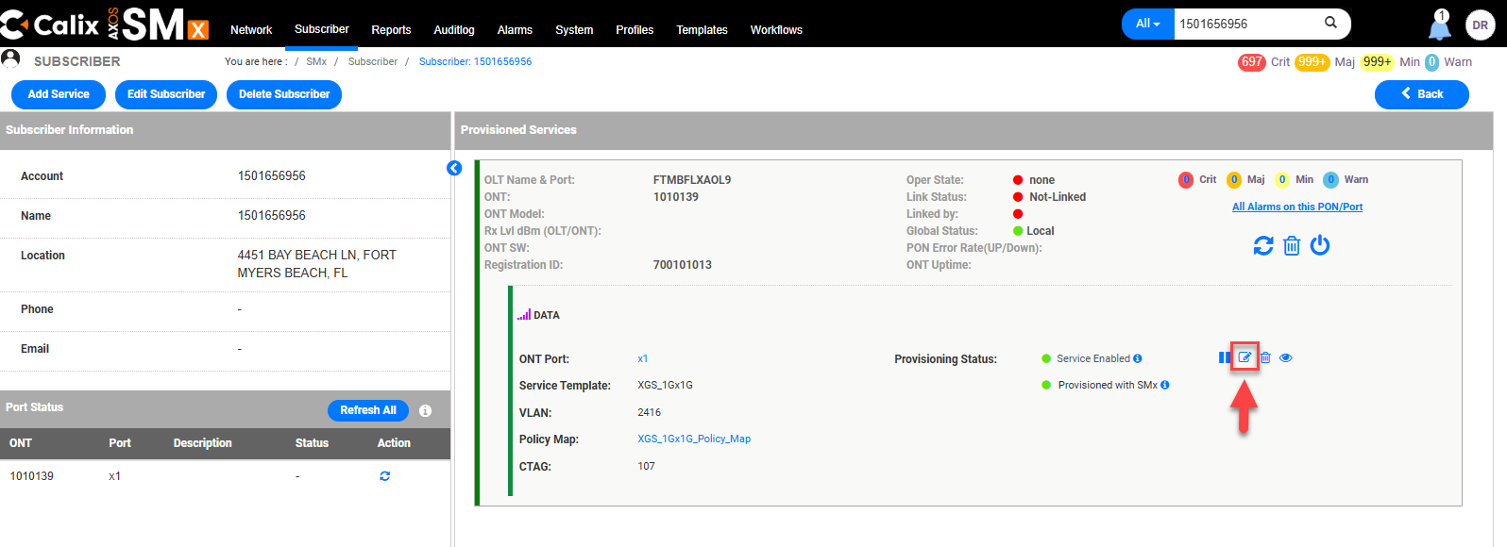
Remove any inputs from the Port Description field.
Verify or populate the TN/DTN in the Subscriber Id field.
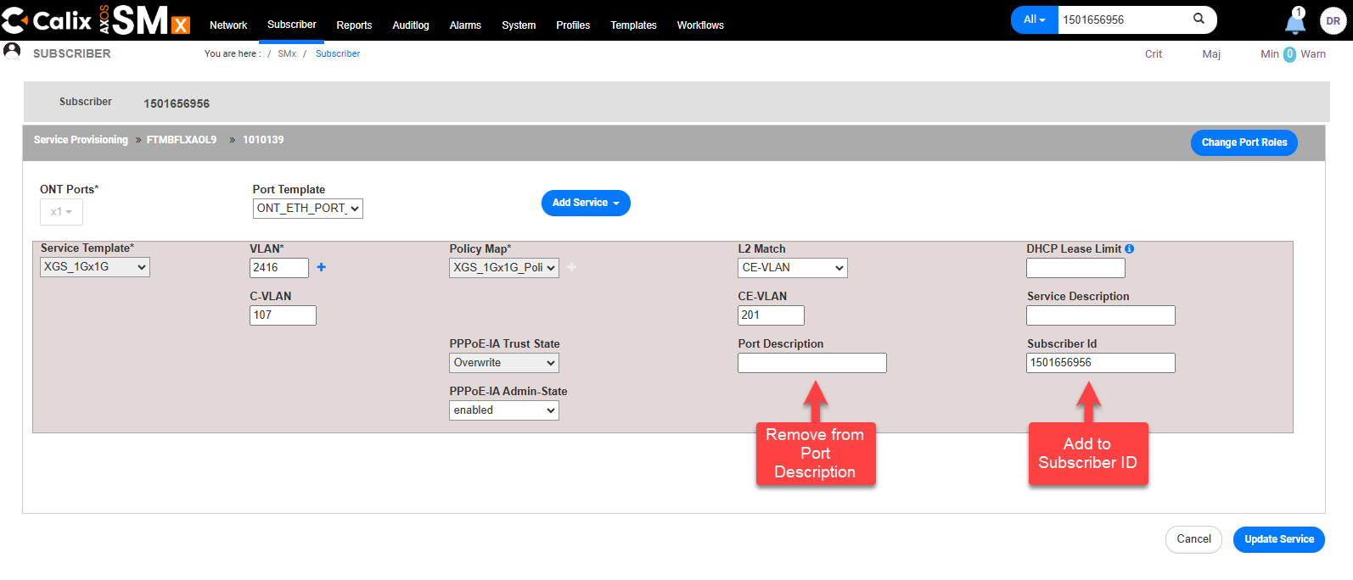
Select Update Service.
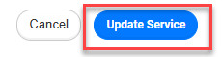
A Subscriber is updated successfully message will appear if the change was successful.
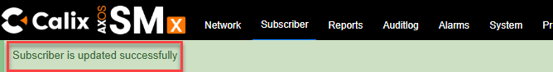
When viewing again, the Interface will no longer be shown.
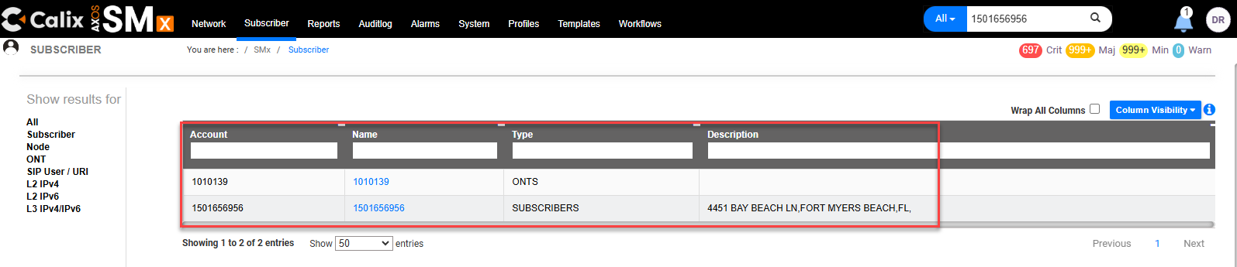

Create Subscriber
Step | Action
 | After logging into the SMx EMS, select Subscriber (top menu).
 | Select Add Subscriber Only.
- Enter Customer’s:
  - Account (TN / DTN),
  - Name (also TN/DTN) and
  - Address
Note: Spaces or special characters in the city field may cause an error when submitting.
- Select Submit.
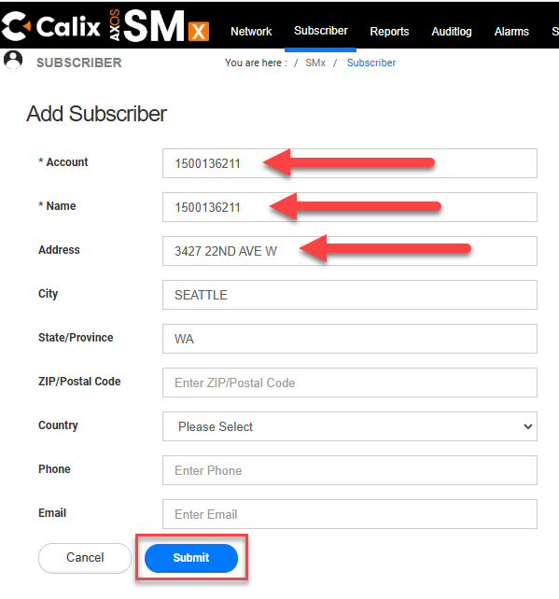
 | If successful, a message Subscriber has been created successfully will appear briefly.
Locate the Customer’s TN / DTN in the list of subscribers and select it.
Tip: Type the TN/DTN in the Account field to narrow the search results.
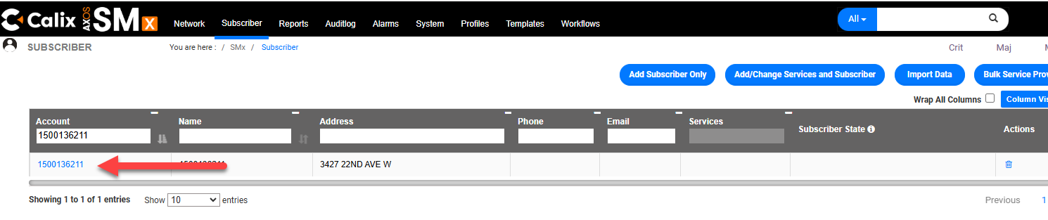
Select Add Service.
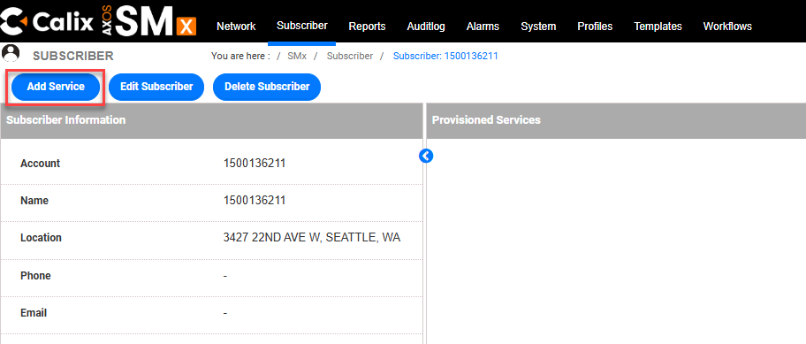
- Enter the Device name in the search bar.
Note: Be sure there are no spaces before or after the device name.
- Then select the looking glass to search.
- Locate the device, it should be in red text.
Tip: may need to use the scroll bar.
Note: The device can also be searched manually by selecting the State and select Device from the navigation tree (Example Device STTLWA05OL5) and scrolling down the list when needed to view the device name.
- Select the Device.
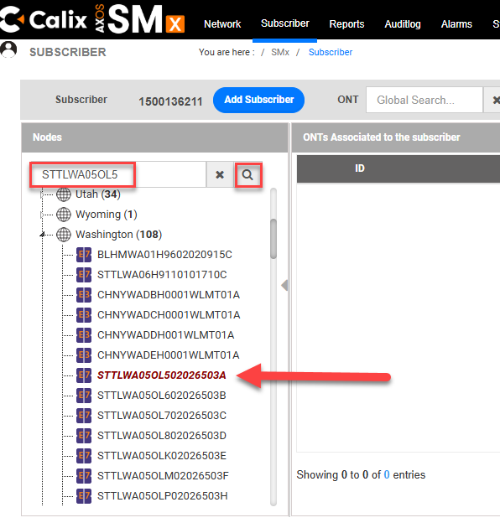
Select Create ONT.
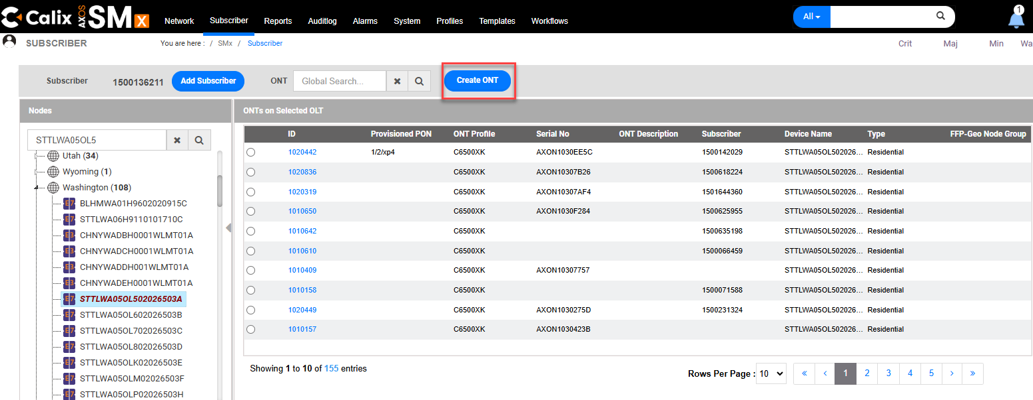
Populate Create ONT as follows:
- ONT ID: RONTA
- Subscriber: Select Customers TN / DTN from drop down
- ONT Profile: Select ONT Model Type (Select CXNK_Default_ONT_Profile if unknown)
- Registration ID: REG ID (700 + RONTA)
- Select the drop down to open the Advanced panel.
- Provisioned PON: verify it defaulted to Automatic
- Shutdown: verify it defaulted to False
Note: Shutdown = False means the ONT is enabled.
*See image on next page.
Tip: Zoom in to see image details if needed.
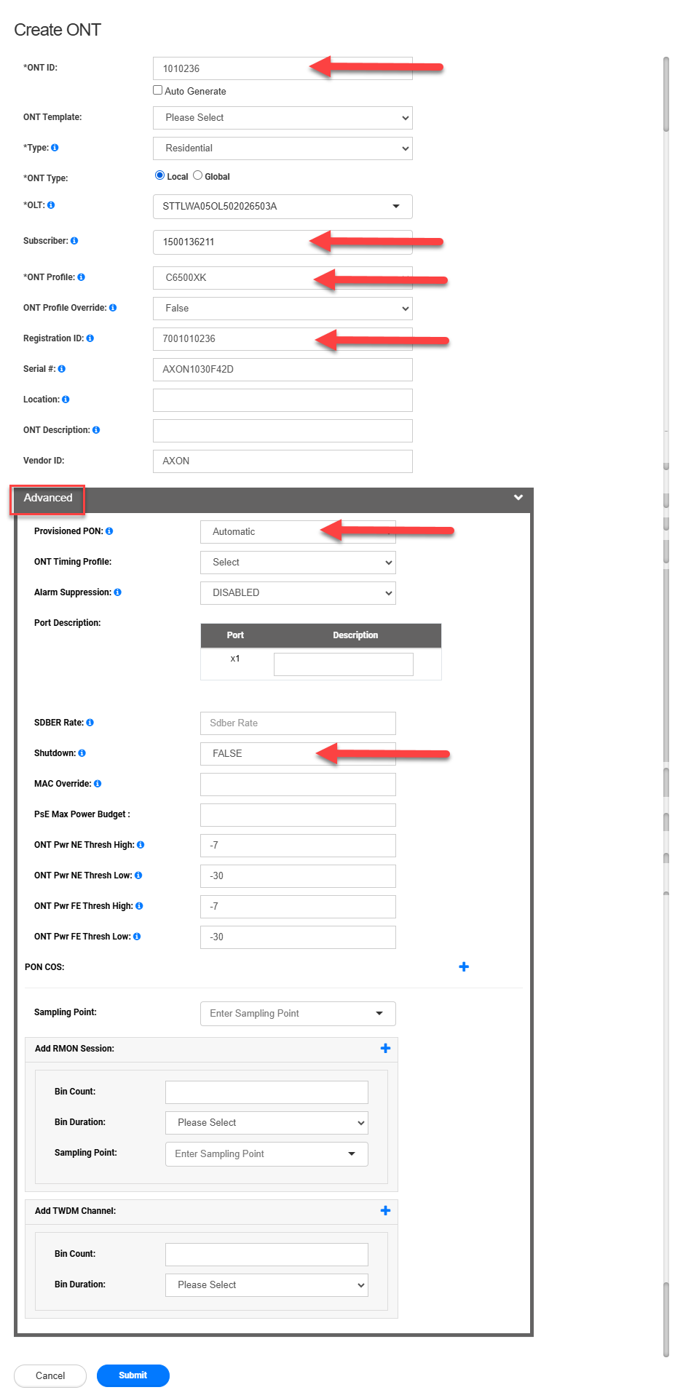
Scroll down to the bottom of the form and select Submit.
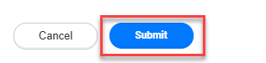
 | A Create ONT successfully message should appear if successful.
The radio button next to the ONT that was just created should already be selected.
Select Next.
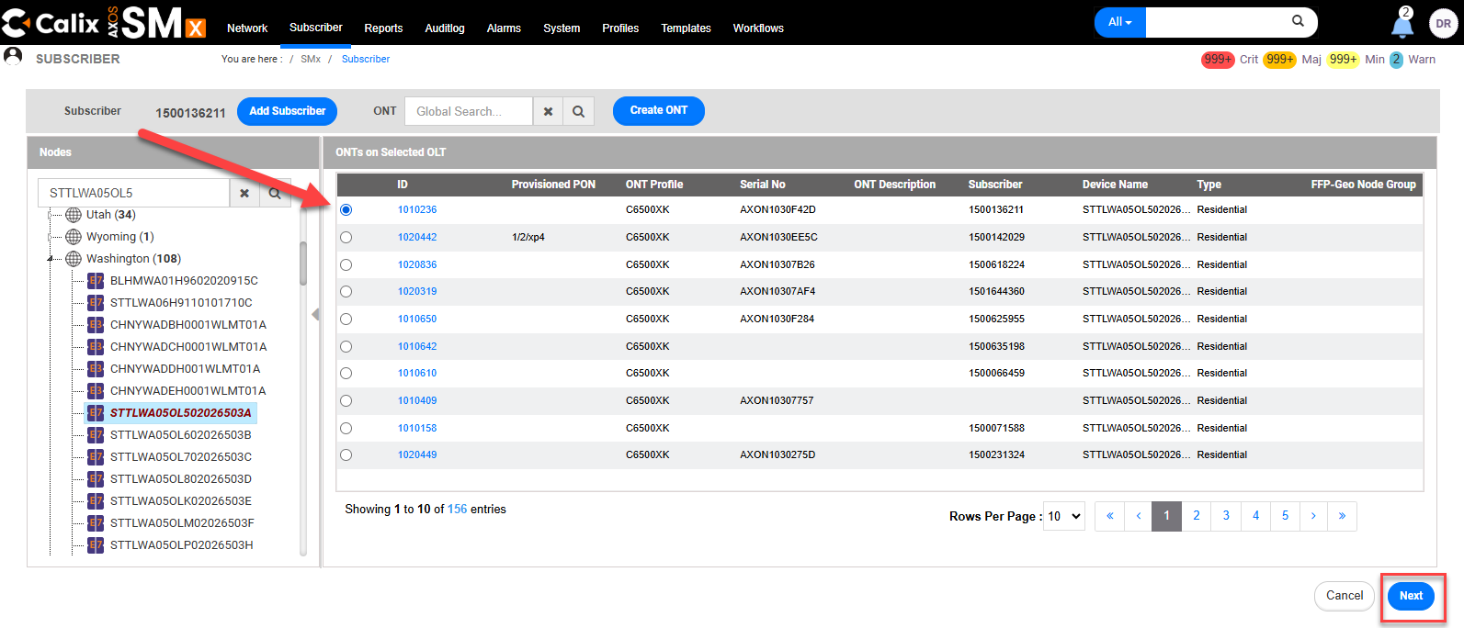
- ONT Ports*: Use the drop-down to select the Port for the ONT. (ex. X1)
- Port Template: Use the drop-down to select ONT_ETH_PORT_TEMPLATE
- Service Template: Select the purchased XGS data speed (Example: XGS_1Gx1G)
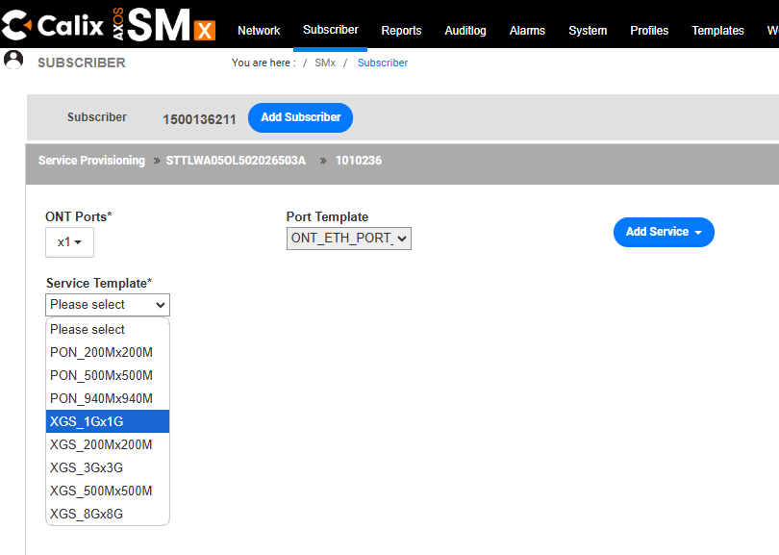
Populate the following fields:
- VLAN: VPI
- C-VLAN: VCI
- L2 Match: Use the drop-down to select CE-VLAN
- CE-VLAN: 201
- Subscriber ID: Customer’s TN / DTN
Note: The fields move as criteria is populated.

Warning: Do not populate Port Description or Service Description. Doing so can create an interface which can negatively impact on the customer’s service.

Select Commit.
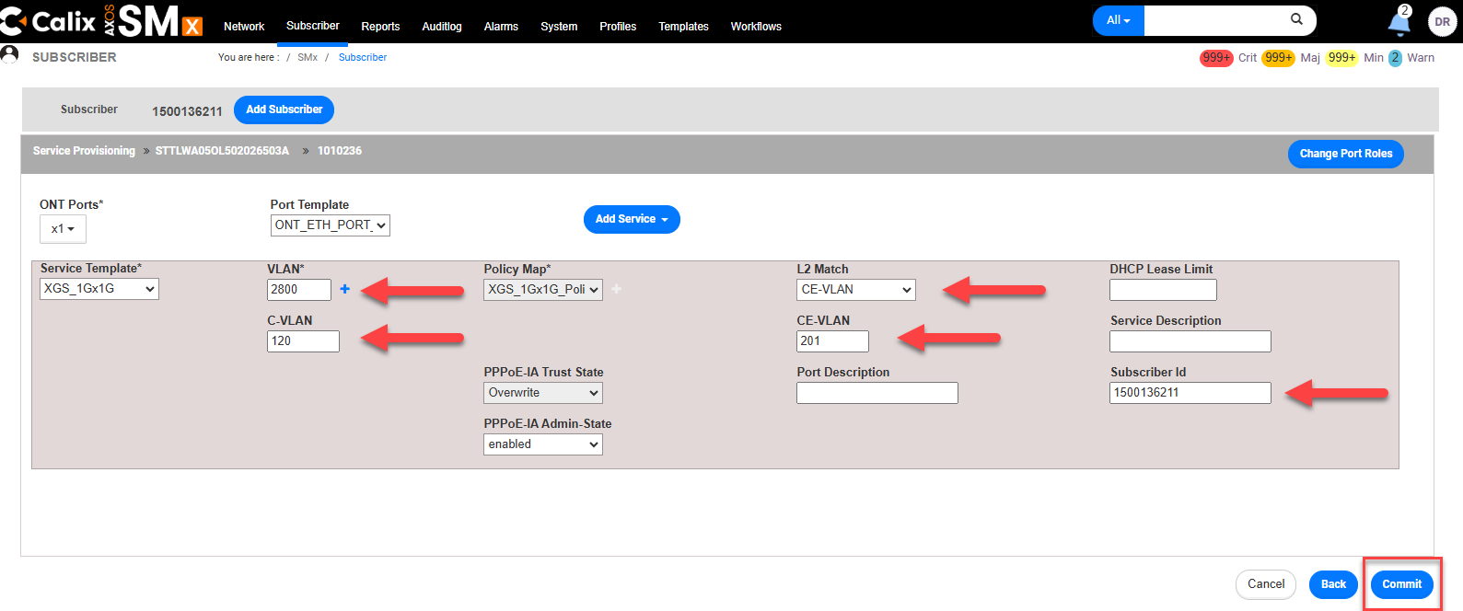
 | A The service provisioning has been started to device for subscriber DTN message will be received if successful.
The created data service will be displayed.
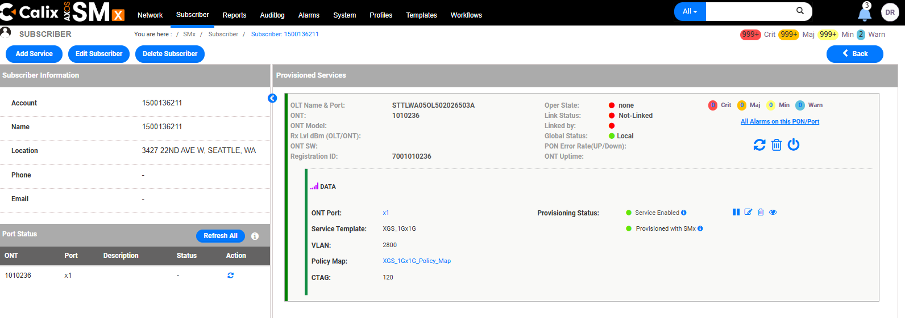

Edit Subscriber
This is used to change the Account, Name, or Address. In order to change the VLAN’s, see Edit Data Service.

Step | Action
View Customer’s TN / DTN (See steps for View Service if needed).
Select Edit Subscriber.
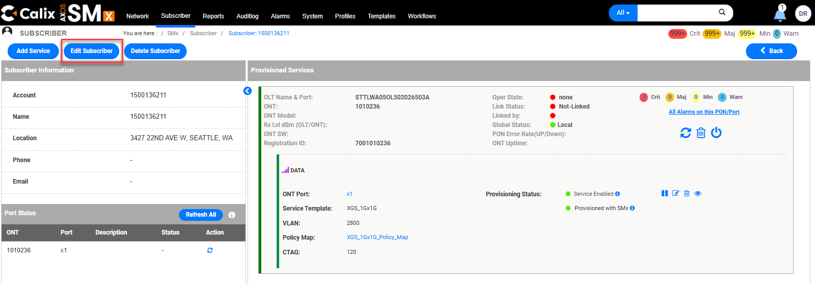
- Edit Subscriber’s Name (DTN/TN), Account, or Address fields.
Tip: Zip Code, Country, Phone, and Email fields are not required.
- Select Submit.
Note: The Account and Name field should be the subscribers DTN/TN.
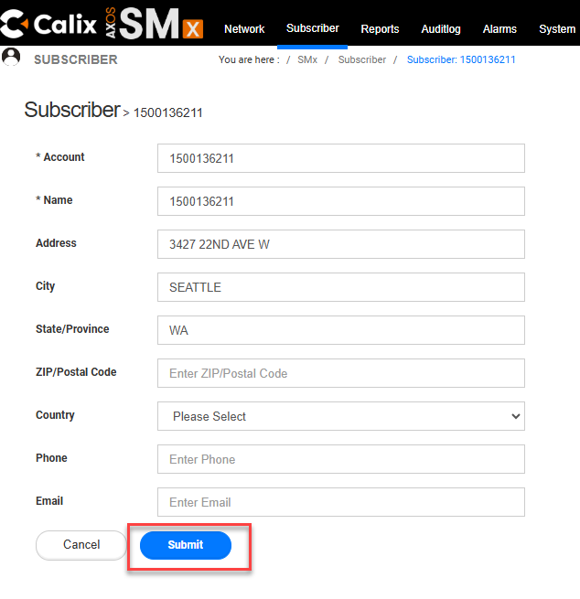
A Subscriber is updated successfully message will appear if the change was successful.


Edit Data Service
This is used to change VLAN’s. In order to change the Account, Name, or Address, see Edit Subscriber.

Step | Action
View Customer’s TN / DTN (See steps for View Service if needed). Select Edit Services .
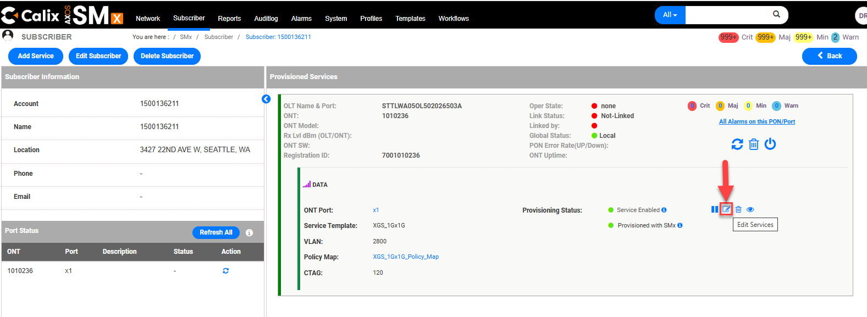
In the Port Template drop-down select ONT_ETH_PORT_TEMPLATE.
The following fields can be edited:
- VLAN* (VPI)
- C-VLAN (VCI)
- L2 Match (Always CE-VLAN)
- CE-VLAN (Always 201)
- Subscriber ID (the customer’s DTN)

Warning: Do not populate the customer’s DTN in the Port Description field or the Service Description field. Doing so will create an interface and will negatively impact on the customer’s service.
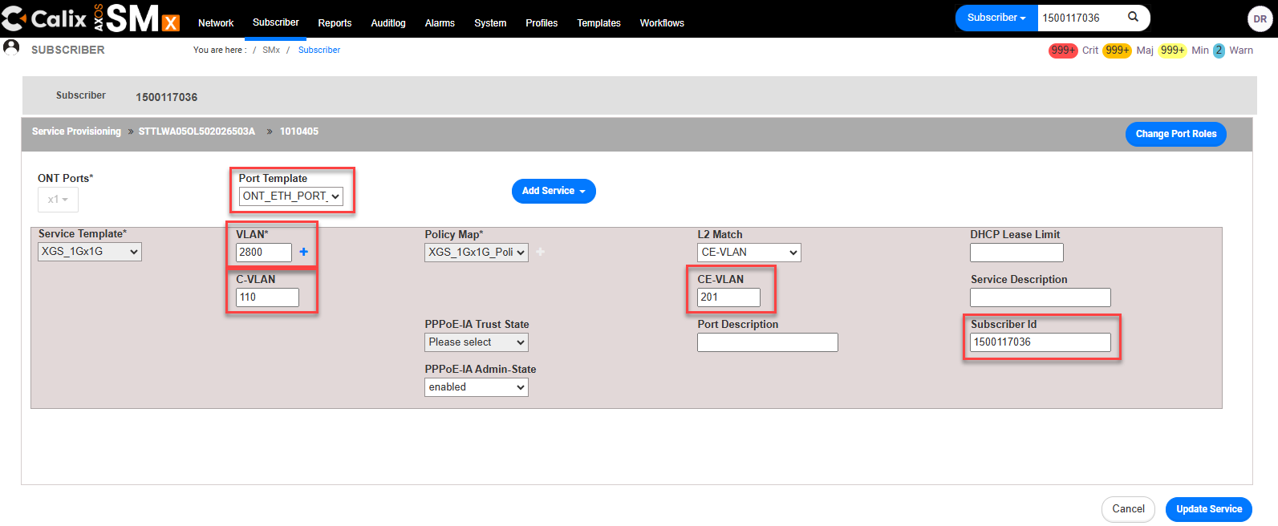
Select Update Service (bottom right). Select Cancel to return to the previous screen without saving any changes.
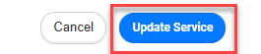

Pause Service
Step | Action
- View Customer’s TN / DTN (See steps for View Service if needed).
- Select Pause Icon
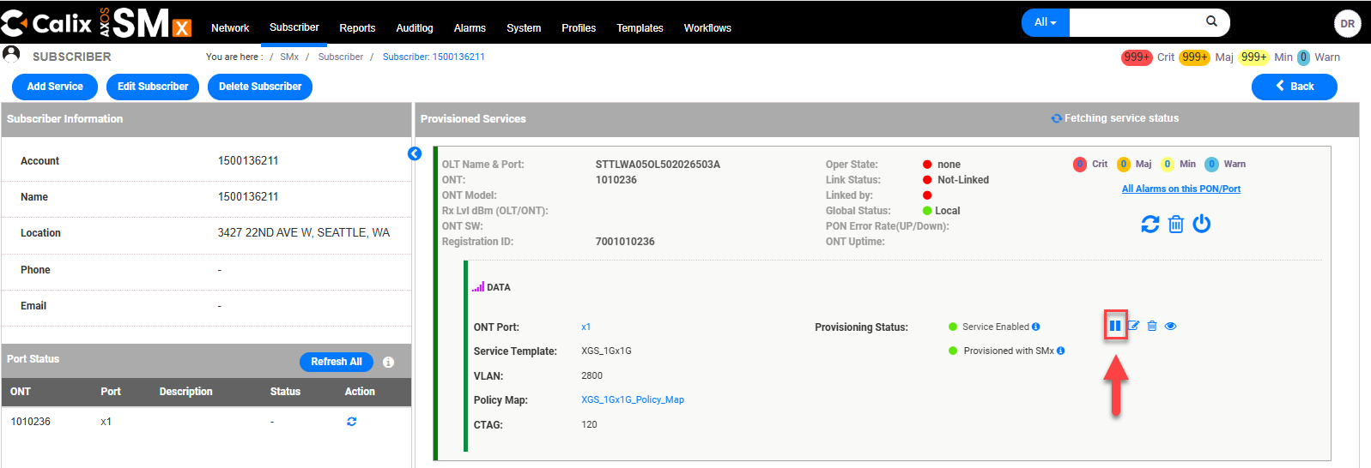
- A pop-up verification question Are you sure you want to pause service? will appear.
- Select Confirm.
- A Services have been paused successfully message will appear.
- When service is paused, the pause button changes to a Resume button .
- The Provisioning Status shows Service Paused.
- The color panel next to the DATA service shows yellow instead of green.
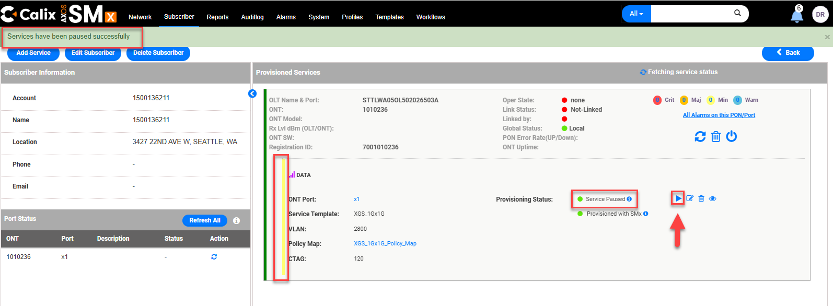

Resume Service
Step | Action
- View Customer’s TN / DTN (See steps for View Service if needed).
- Select the Resume Icon .
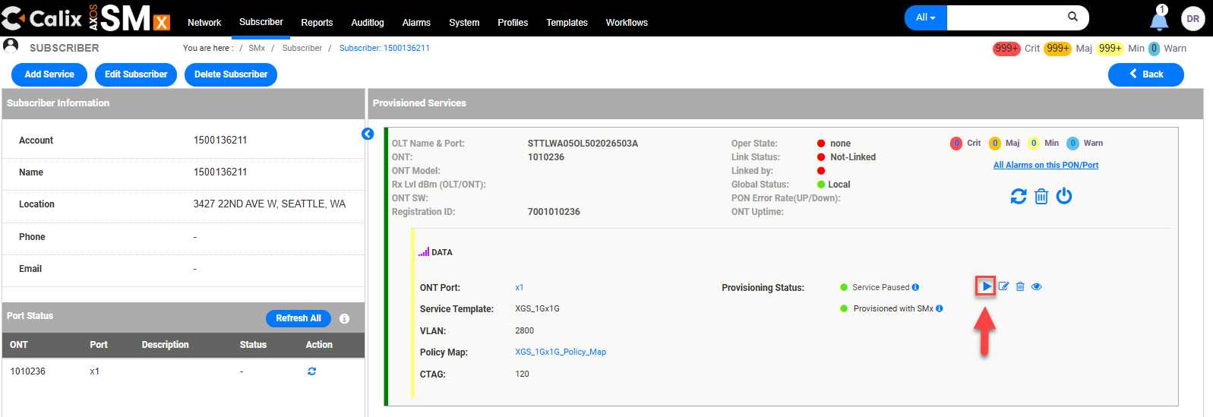
- A Services have been resumed successfully message will appear.
- The Resume button will change to a Pause button .
- The Provisioning Status shows Service Enabled.
- The color panel next to the DATA service shows green instead of yellow.
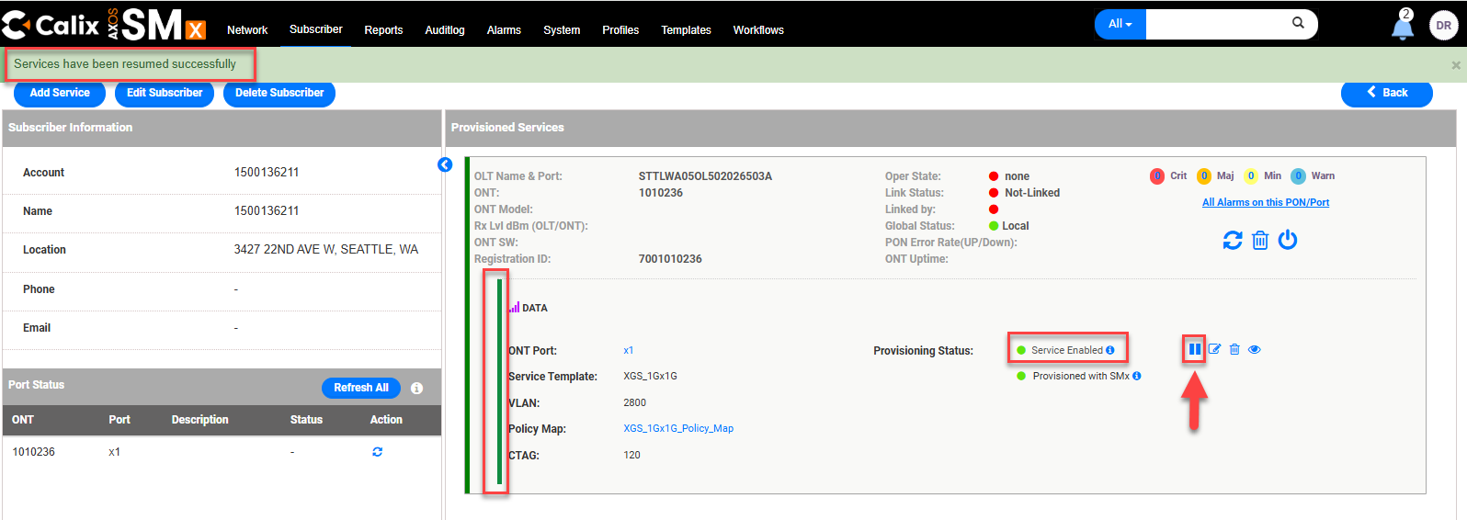

Deleting Service
There are two steps when deleting services.
Deleting the Subscriber and deleting the ONT

Deleting the Subscriber

Step | Action
- View Customer’s TN / DTN (See steps for View Service if needed).
- Select Delete Subscriber.
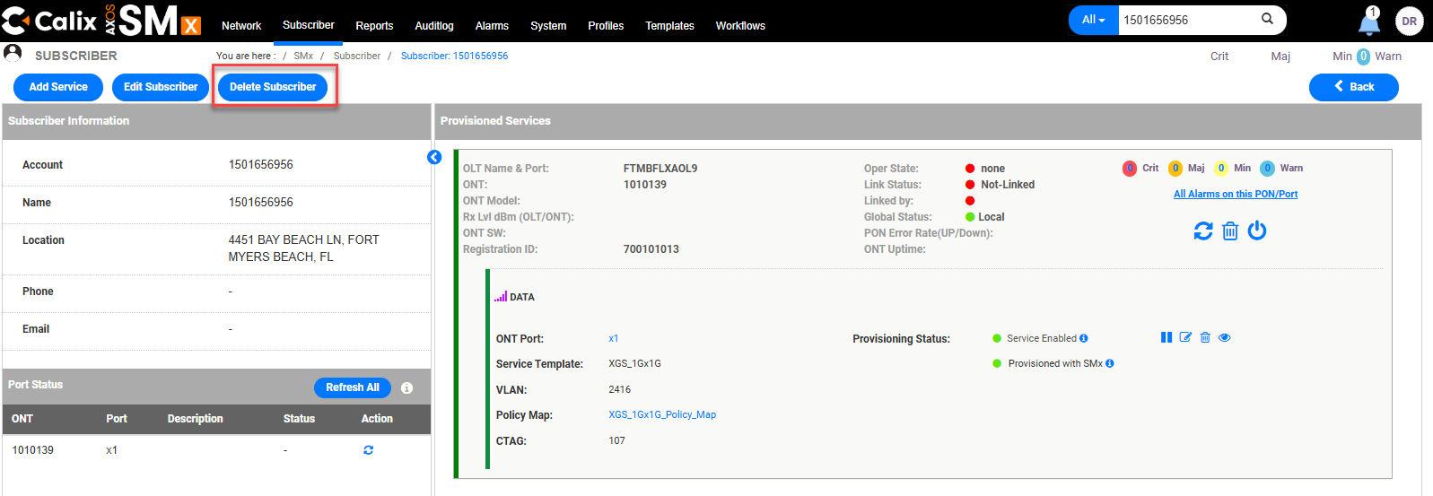
Select Force Delete.
- It does NOT delete the ONT. This will need to be done separately.
- Selecting Delete can only be used if there are no services provisioned.
 | A Deleted subscriber (TN/DTN) successfully message will appear if successful.

Deleting the ONT
In Quantum Fiber, it should be rare that deleting the ONT is needed, since QF tends to use SmartNID technology. There may be limited scenarios where a rip and rebuild in QF may be needed.
Step | Action
- View Customer’s TN / DTN (See steps for View Service if needed).
- Select the ONT.
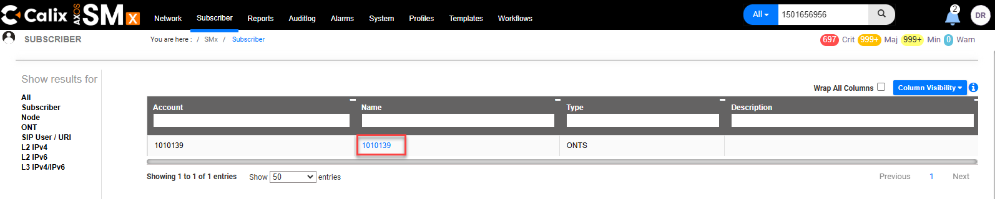
- Select Actions to open the drop-down menu.
- Select Delete ONT.
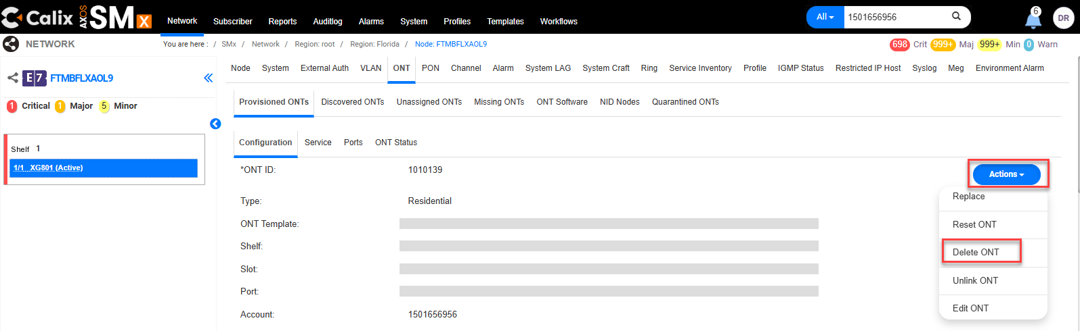
 | Select Force Delete.
 | A ONT has been deleted successfully message will appear if successful.

Firmware
The SmartNID Firmware can be found by:
- Go to the ONT screen
- Go to the Provisioned ONT’s tab
- Locate the corresponding ONT
- Verify the Current Version field for the corresponding ONT.

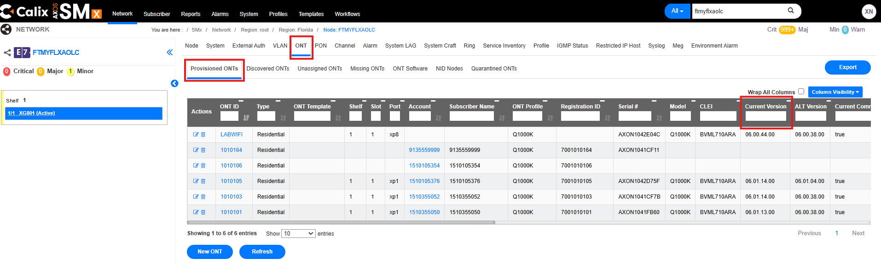

Troubleshooting
Always attempt normal troubleshooting steps first. Verify customer is provisioned correctly (VLANs match what is assigned), ONT is linked, and IMPROV account exist. If the steps below do not resolve issue, try Rip/Rebuild or ask the Technician to try a replacement ONT or Modem if needed.

How to Verify the Subscriber’s IP Address

Step | Action
- View Customer’s TN / DTN (See steps for View Service if needed).
- Select Services Status Details .
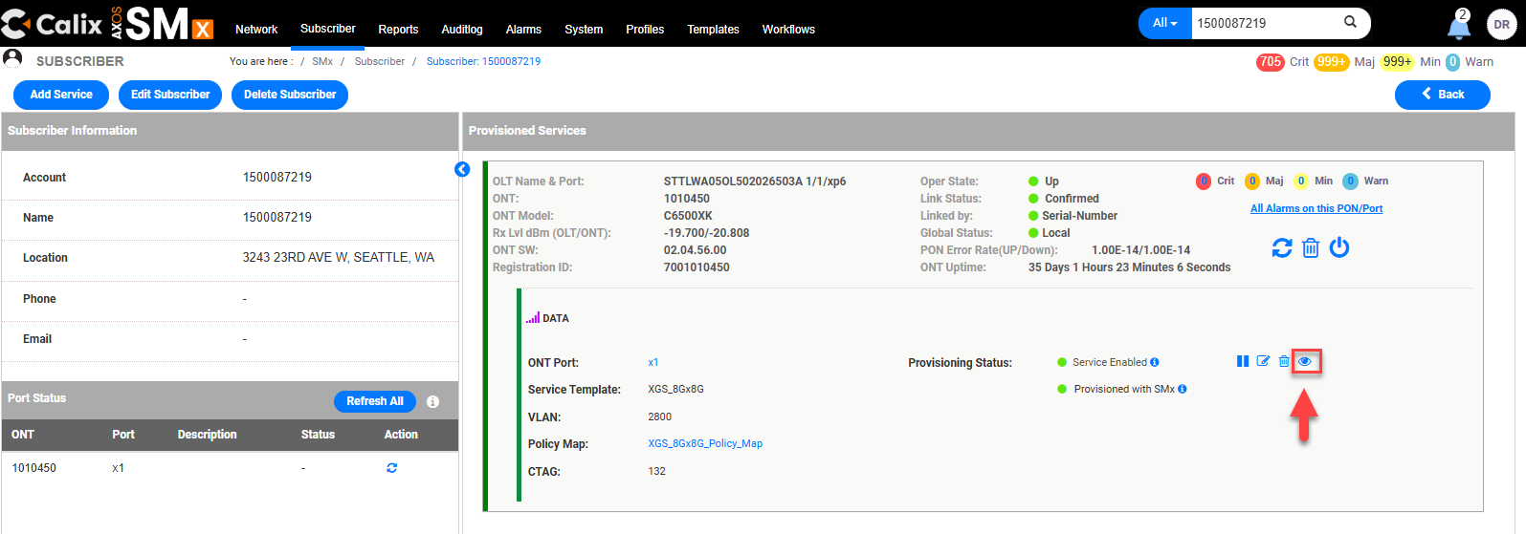
- Select IPv4.
- The IP Address will be listed under the IP Address column.
Note: To delete the IP, select the trash can under the Actions column.
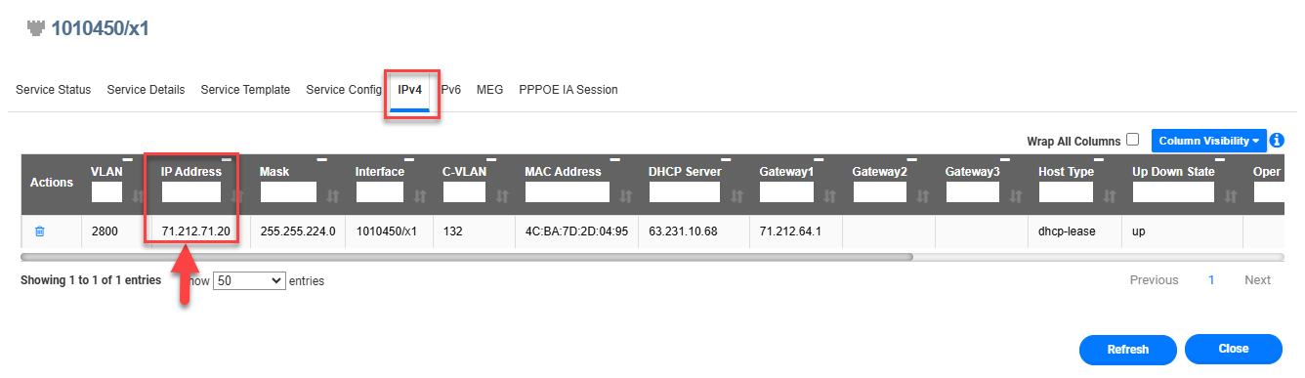

Linking an ONT
Tip: See the related video SMx - Linking ONT to Subscriber Account.webm
The link for which can be found in the Related Documents section of this document.

Step | Action
1 | Using the menu on the left, navigate to the target OLT by Selecting the State (FL in this example)  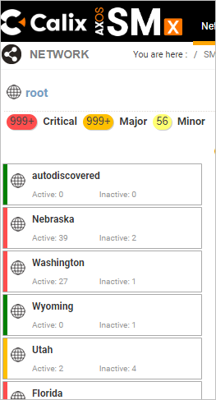
2 | Using the search bar, input either the CLLI or the IP of the device.  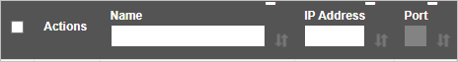
3 | Ensure the Node is Synchronized.  - If it isn’t, follow the How to Resynchronize the CLLI steps in this document.  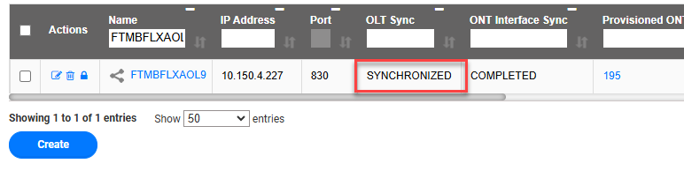
Select the OLT Name.
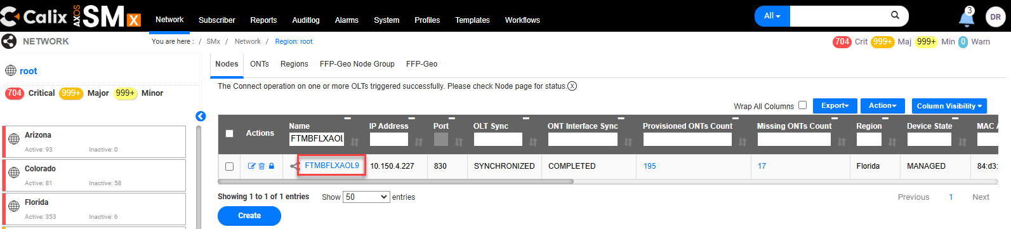
Select the ONT tab.
Populate the ONT ID in the ONT ID field.
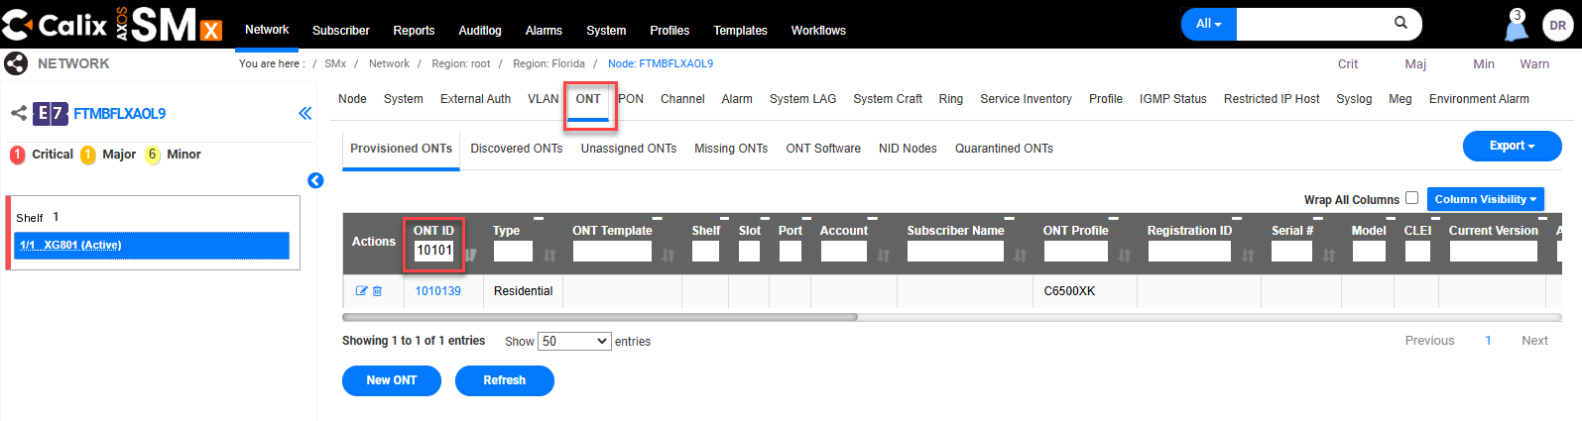
Select the ONT ID link.
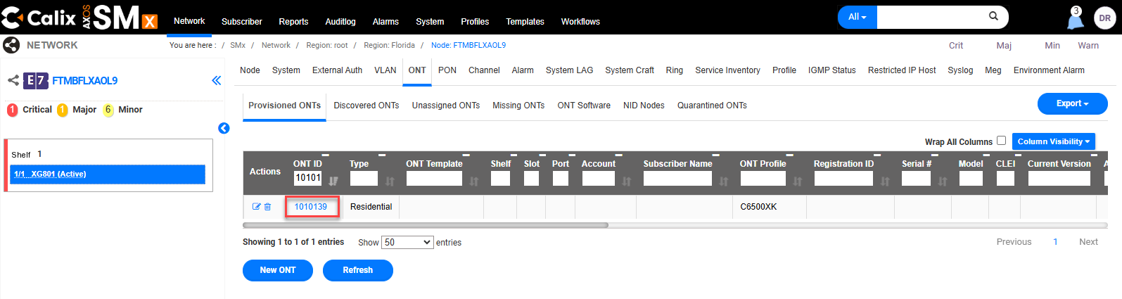
- Select Actions to open the drop-down menu.
- Select Edit ONT.
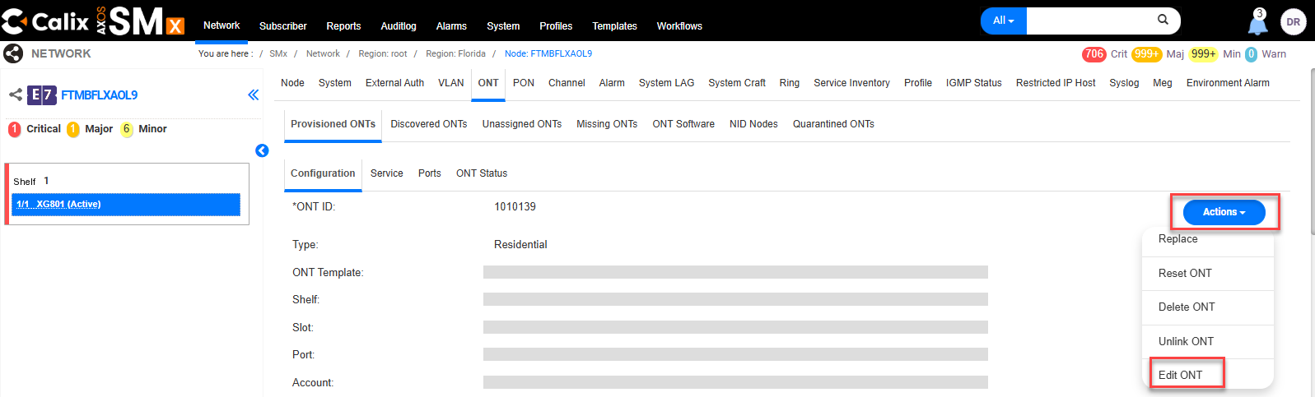
- If linking a SmartNID ONT for a Technician, remind the Technician that Tech must use QMate 2.0 to claim the SmartNID ONT.
Note: Failure to complete the claiming process at any point prevents the service from working.
- Populate the Serial Number in the Serial # field.
- Verify the following fields are correctly populated:
  - Subscriber field = TN/DTN
  - Registration ID = RONTA
  - Shutdown = false
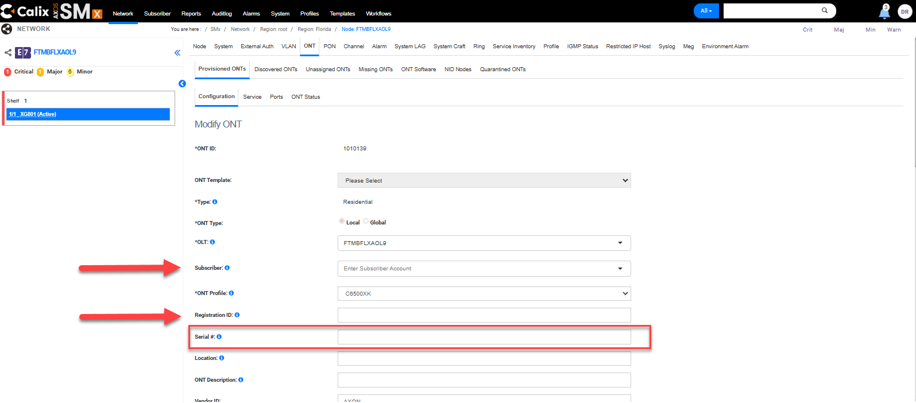

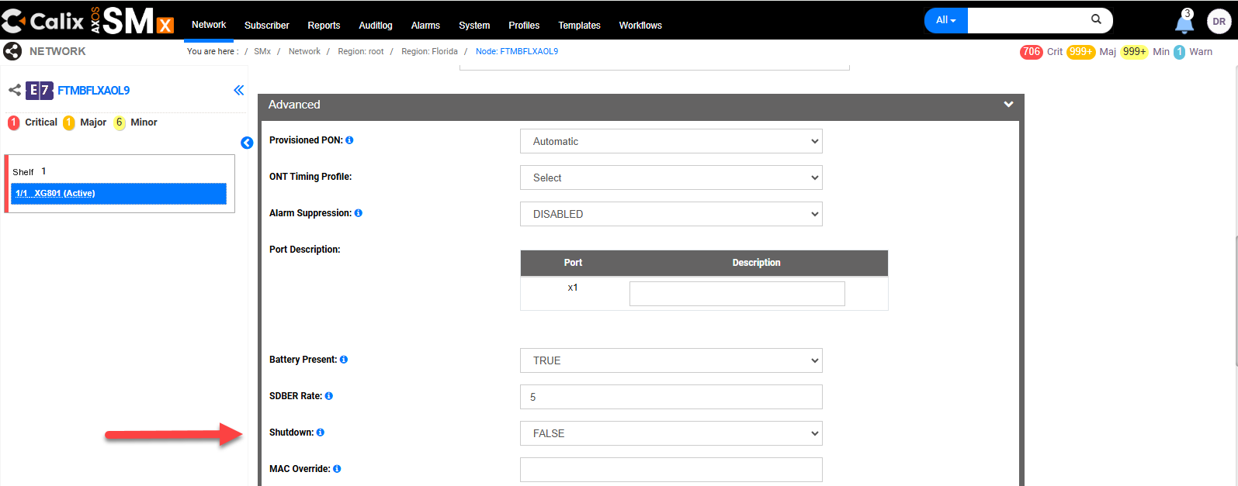
Select Submit.
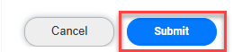
 | An Update ONT successfully message will appear if successful.
Search for the TN/DTN.
- The ONT should appear in the search results.
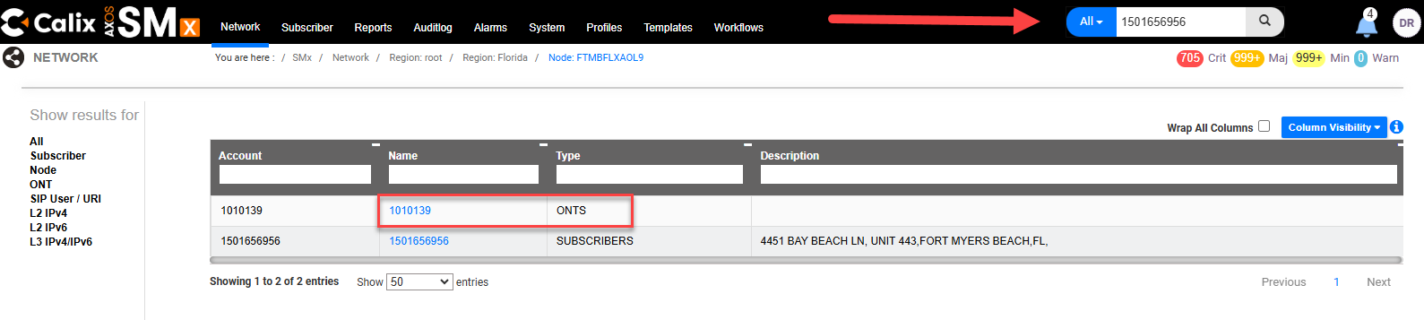

Reset ONT

Step | Action
- View Customer’s TN / DTN (See steps for View Service if needed).
Tip: There must be light levels, verify light levels first.
- If there are no light levels, an error message Error Validate failed, ONT (#######) Operational Status is not present will be received after attempting to execute the Reset.

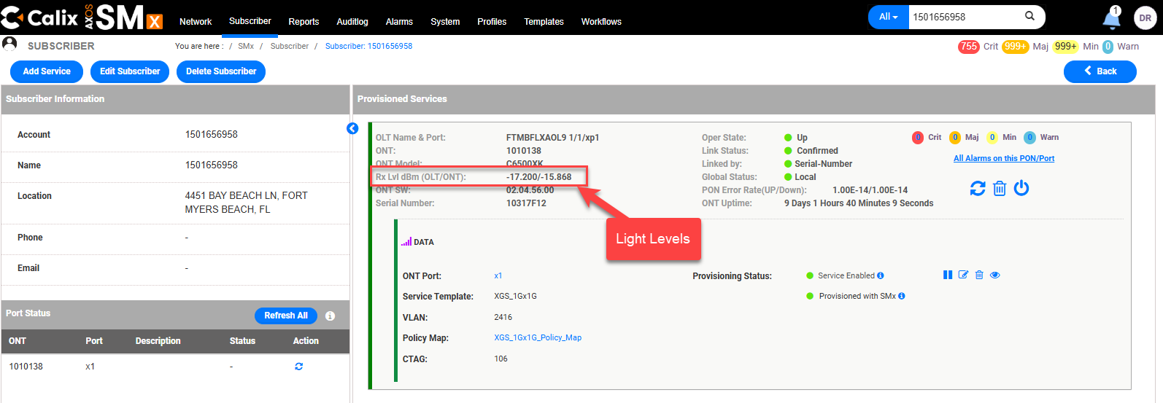
Select Reset ONT Icon .
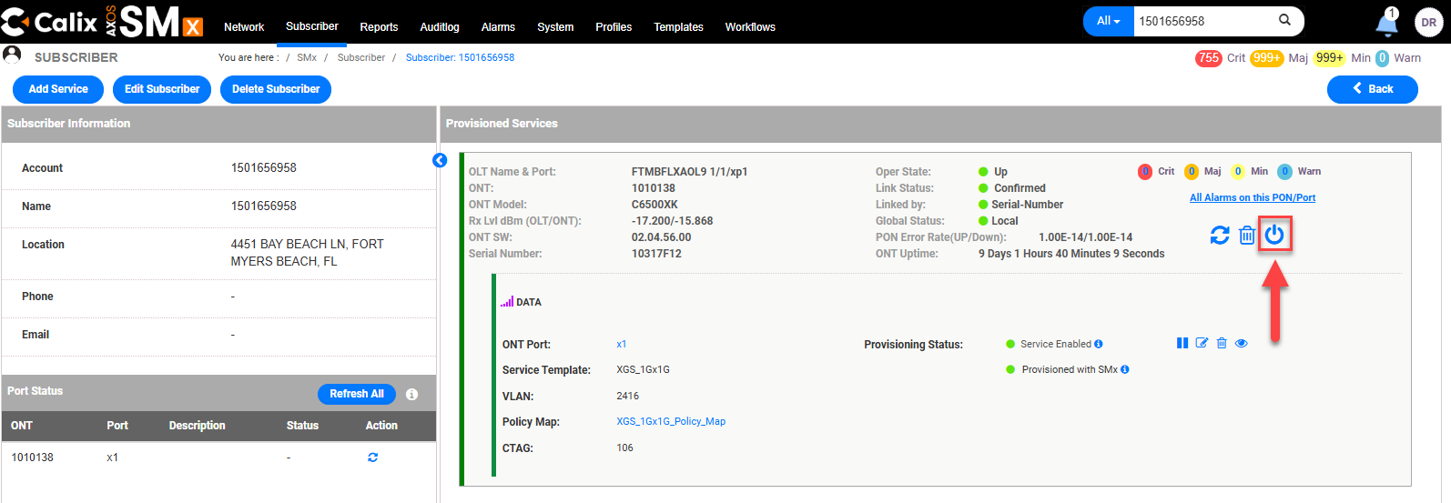
 | Select Force Reset on the Alert.
 | A Reset ONT ####### successfully message will appear if successful.
- After a successful reset, the Light levels will briefly display zeros, the Oper State will briefly display missing, and the ONT Uptime will reset to zeros.
- The screen will auto-refresh after a few moments.
- Confirm Authentication in Poll Dslam or QRAD.
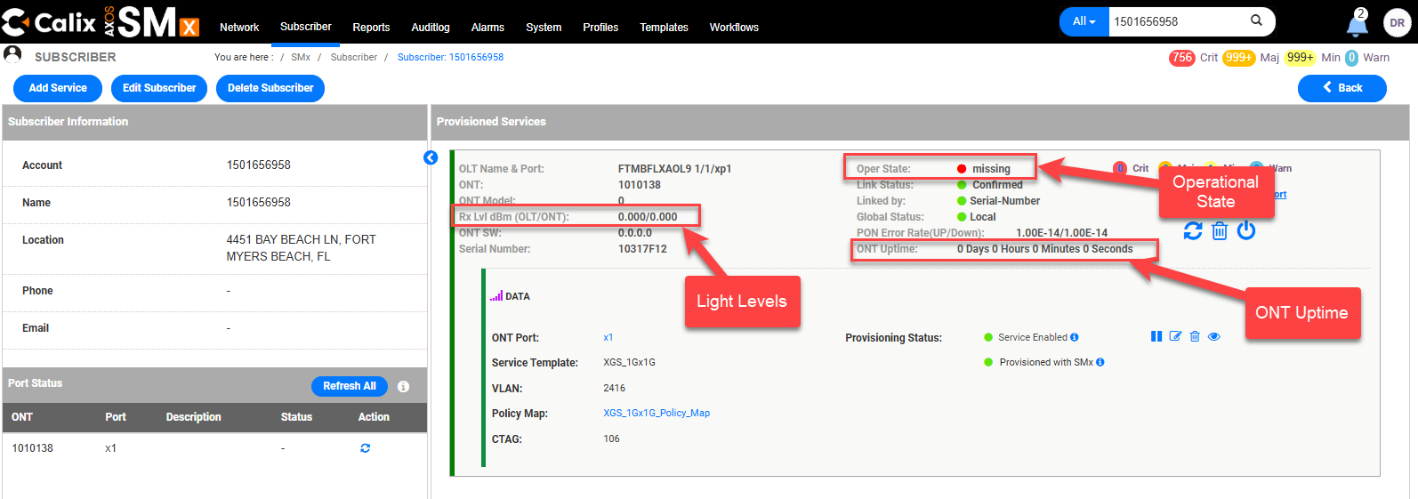

Replace ONT

Step | Action
1 | Input the Customer’s TN / DTN in the stop search bar and leave filter as All.  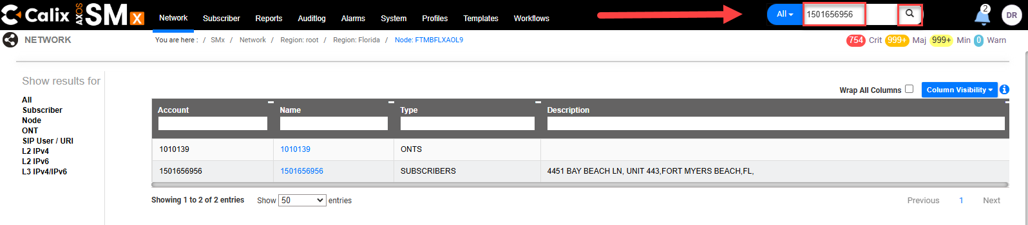
2 | Select the ONT ID.  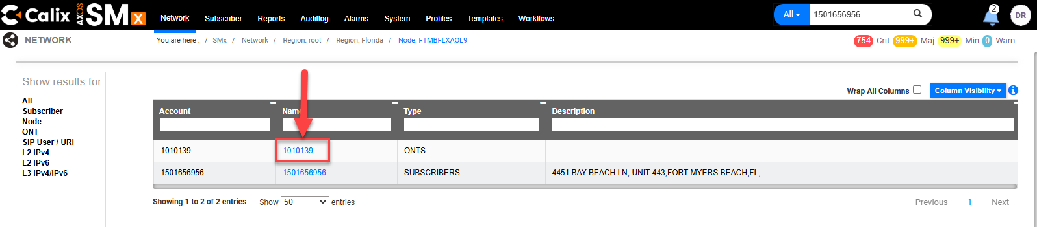
- Select Actions to open the drop-down menu.
- Select Replace from the dropdown.
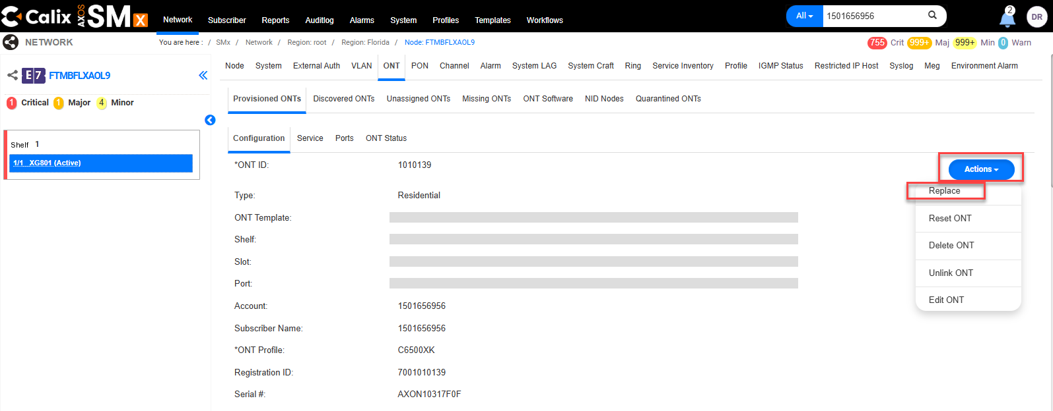
4 | - When replacing SmartNID ONT with a Technician on the phone, delete the Serial Number and ask the Tech to scan the replacement SmartNID ONT using Tech 2 Go (T2G). Scanning the replacement SmartNID ONT using T2G completes the claiming process which is required before activating wireless PODS. Failure to complete the claiming process at any point prevents the service from working.  Hint: Removing the old serial number can be referred to as dumying the ONT  - Remove the old SmartNID ONT Serial # and Submit.  Or  - If a Tech is unable to scan the SmartNID ONT, then populate the new serial # and Submit.  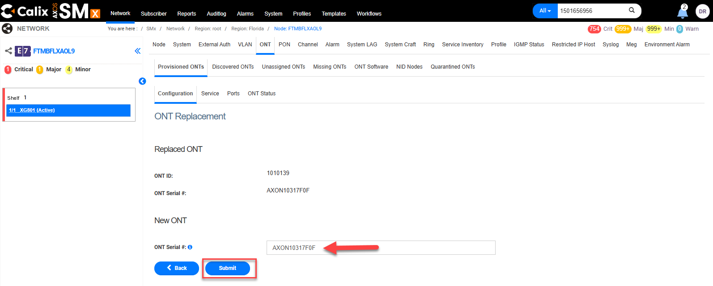
5 | A Replace ONT successfully message will appear if successful.

Searching VLANs

Step | Action
- If there is a left in VLAN or an Agent needs to view what VLANs are built to a device:
- Search for the Device. In this example we searched by All and input the Device Name.
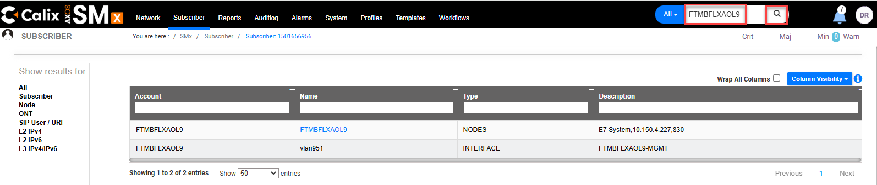
Note: Agents can also search for devices manually by selecting the network tab (top menu), selecting the state (left side menu) and then scrolling through the list of devices.
Select the corresponding result.
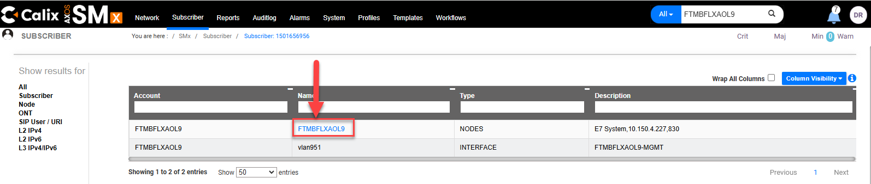
Select Service Inventory. Review C-VLAN column for all provisioned CVLANs.
Tip: To search for a specific CVLAN, input that CVLAN into the CVLAN search box and wait for results to populate.
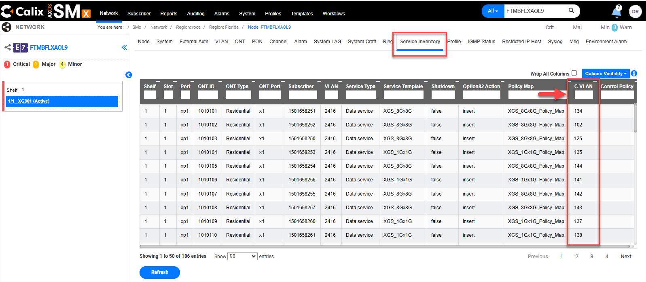

Verifying SHUTDOWN is set to False
If Tech is reporting No Ping, verify if SHUTDOWN is set to False.

Step | Action
 | View Customer’s TN / DTN (See steps for View Service if needed, except make sure the drop down is set to All).
Select the ONT.
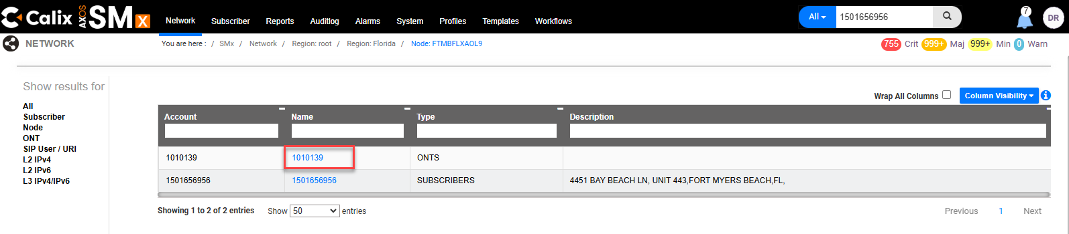
- Select Actions to open the drop-down menu.
- Select Edit ONT.
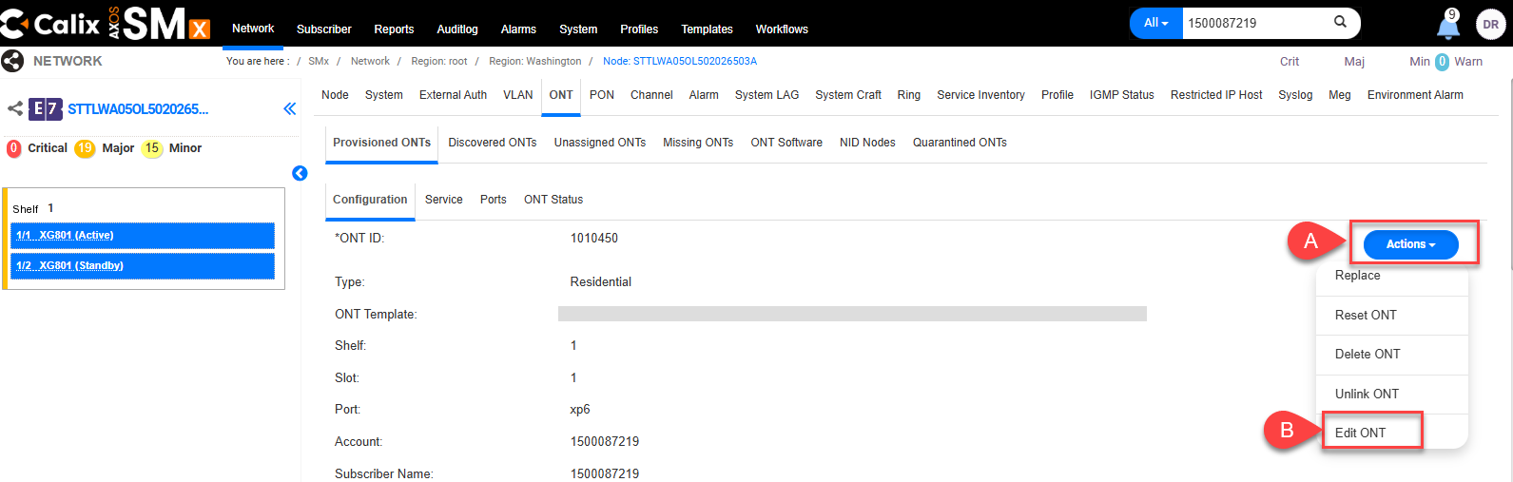
- Scroll to the bottom of the page.
- Next to Advanced, select the arrow to open drop-down.
Scroll down until the Shutdown field is shown.
- Verify field is set to False. If False is shown no additional action is required.
- If set to True it will cause no ping or service drops and needs to be changed to False. To change to False select the drop-down arrow on the right
- Select False
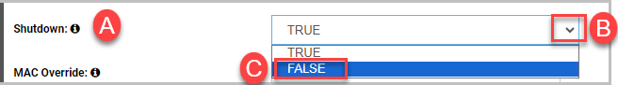
- Scroll down to the bottom of the page and select Submit.

 | An Update ONT successfully message will appear if successful.

How to Resynchronize the CLLI
If it is identified that it is necessary to resynchronize the CLLI, follow the steps below.

Note for the Structure Load Team working New Build jobs:
An issue has been identified where sometimes only blank white space is seen when the expected result should look something like this:
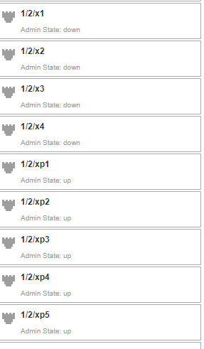
This action will also be needed if project notes in Sitetracker say something like this STRUCTURELOAD: PLEASE RE-SYNC THE CLLI IN SMX, IF YOU NEED ASSISTANCE PLEACE REACH OUT TO IAN BAKER; ALL ISP ACTIVITIES ARE COMPLETE

Step | Action
1 | Select Network.
2 | Populate the OLT name in the Name Field.  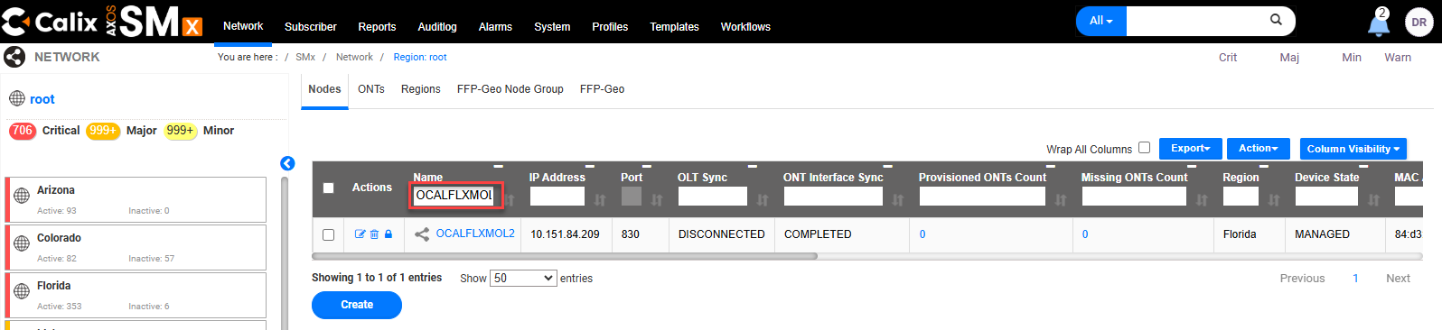
3 | - Check the box next to the corresponding result.  - Select Actions to open the drop-down menu.  - Select Connect.  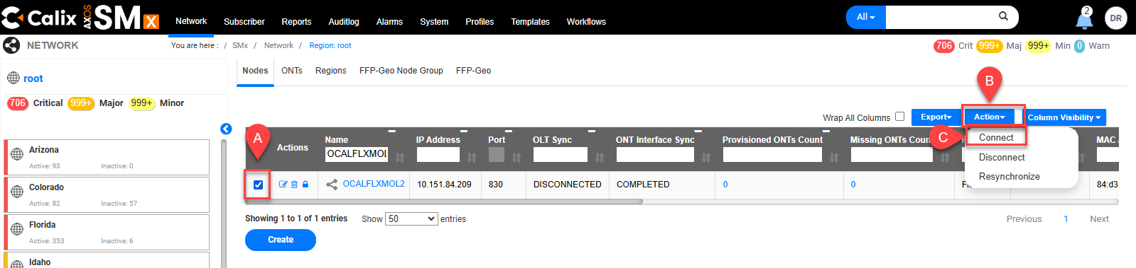
4 | Select Confirm.
4 | - A Connect device request initiated successfully message will appear.  Important: This process can take a while (This can vary but it can take about 15 minutes).  - The OLT Sync field will change as the Synchronization process proceeds. When it is done, if successful, the OLT Sync field should display SYNCHRONIZED.  - If the OLT Synch field displays DISCONNECTED after attempting to Resynchronize, refer to the Reporting DSL Outages to Local DSL NOC (All Markets) process, the link for which can be found in the Related Documents section of this document.  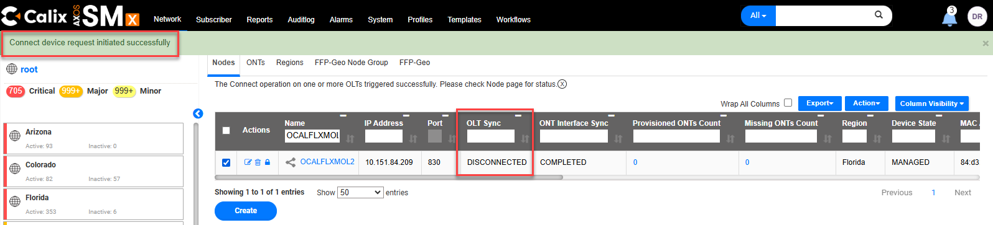
5 | Search the OLT again and action accordingly.

No Authentication/No Ping
Verify the programming is correct and complete.
Refer to the Create Subscriber section of this document.

Some common causes of No Authentication/No Ping would include:
- 201 tagging is missing
- CVLAN needs to be present and correct and not duplicated
- Verify Shutdown is set to False

Tip: See the related video SMx - Missing CE-VLAN 201.webm for 201 tagging.
The link for which can be found in the Related Documents section of this document.

When the Registration ID (aka RONTA) is missing
Tip: See the related video SMx - Correct a Missing Registration ID.webm
The link for which can be found in the Related Documents section of this document.

The easiest way to search is using the Search bar and populate the TN/DTN.

If the Search bar is broken, use the Subscriber Tab to locate the OLT name and Port and then use the Network Tab to navigate to the ONT.

Using the Search Bar

Step | Action
 | View Customer’s TN/DTN (See steps for View Service if needed.)
Select the ONT.
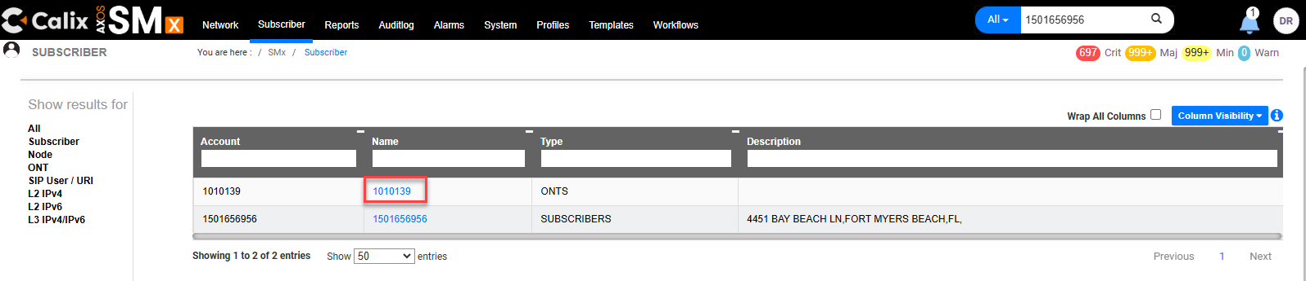
Select the Actions button to open the drop-down menu.
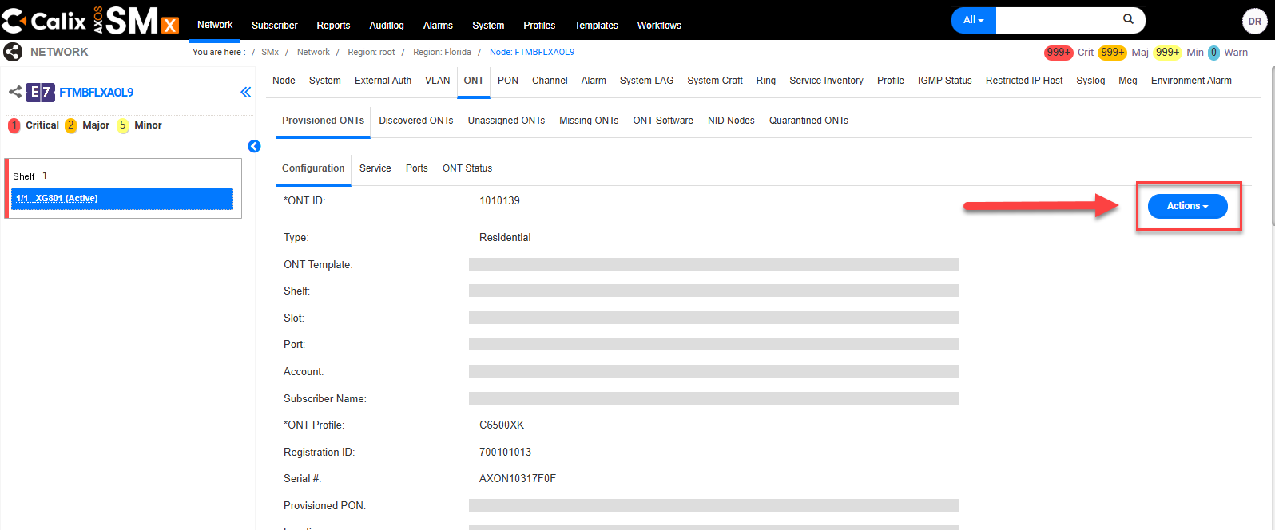
Select Edit ONT.
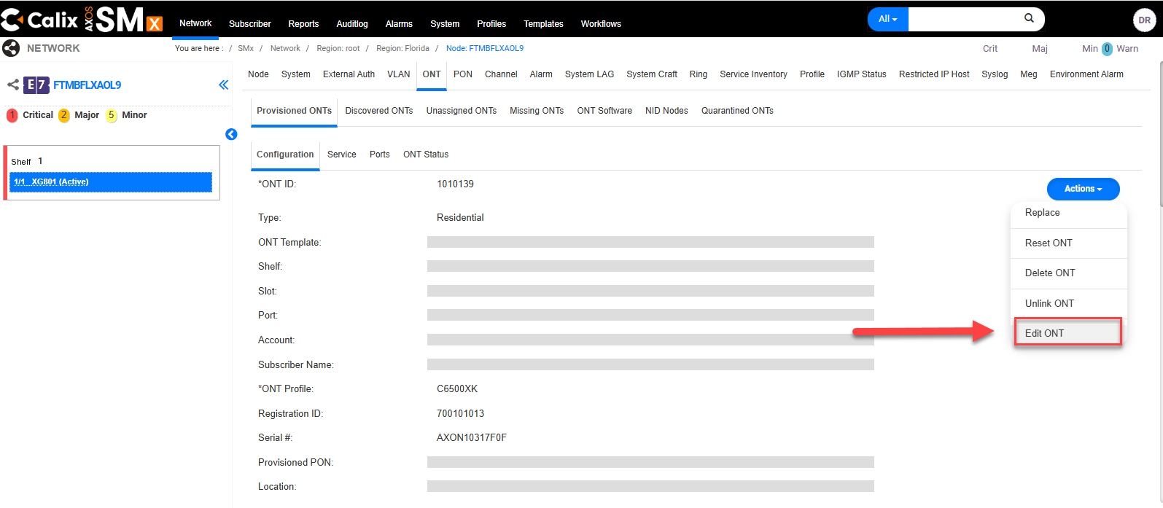
In the Registration ID field, input the Registration ID/aka RONTA {ex: REG ID (700 + RONTA)}
Also populate or correct any other missing or incorrect information such as:
- Subscriber ID
- Verify Shutdown is set to False (in the Advanced panel)
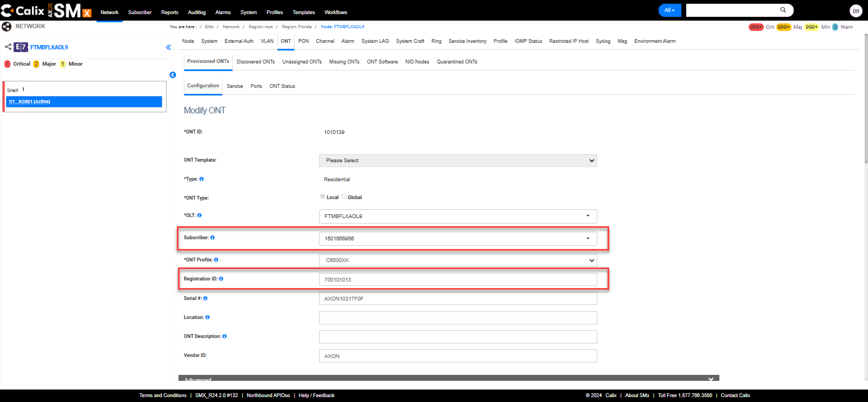

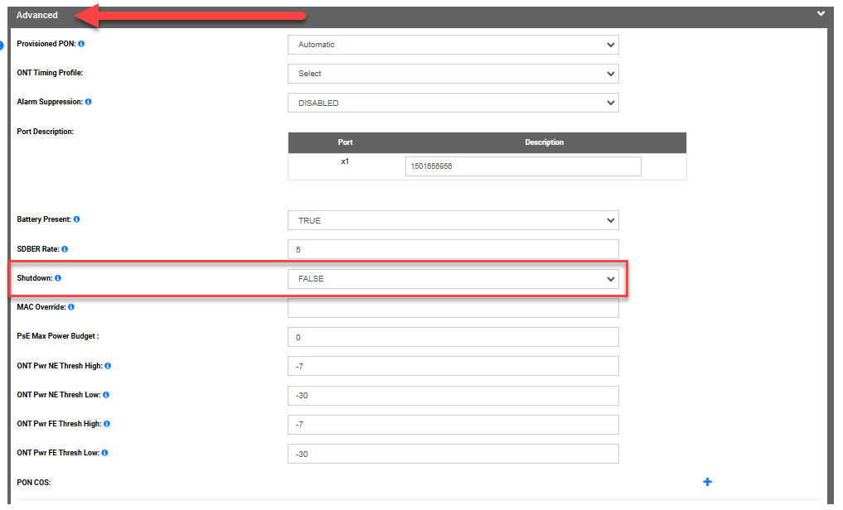
Select Submit.
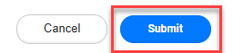
 | An Update ONT successfully message will appear if successful.

Using Subscriber Tab and Network Tab

Step | Action
 | Select Subscriber.
- Populate the TN/DTN in the Account search box and wait for the results to narrow.
- Select the corresponding TN/DTN.
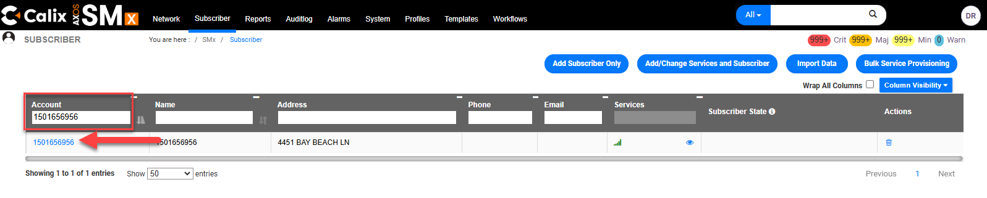
- Copy the OLT Name and Port information.
- Make note of the ONT.
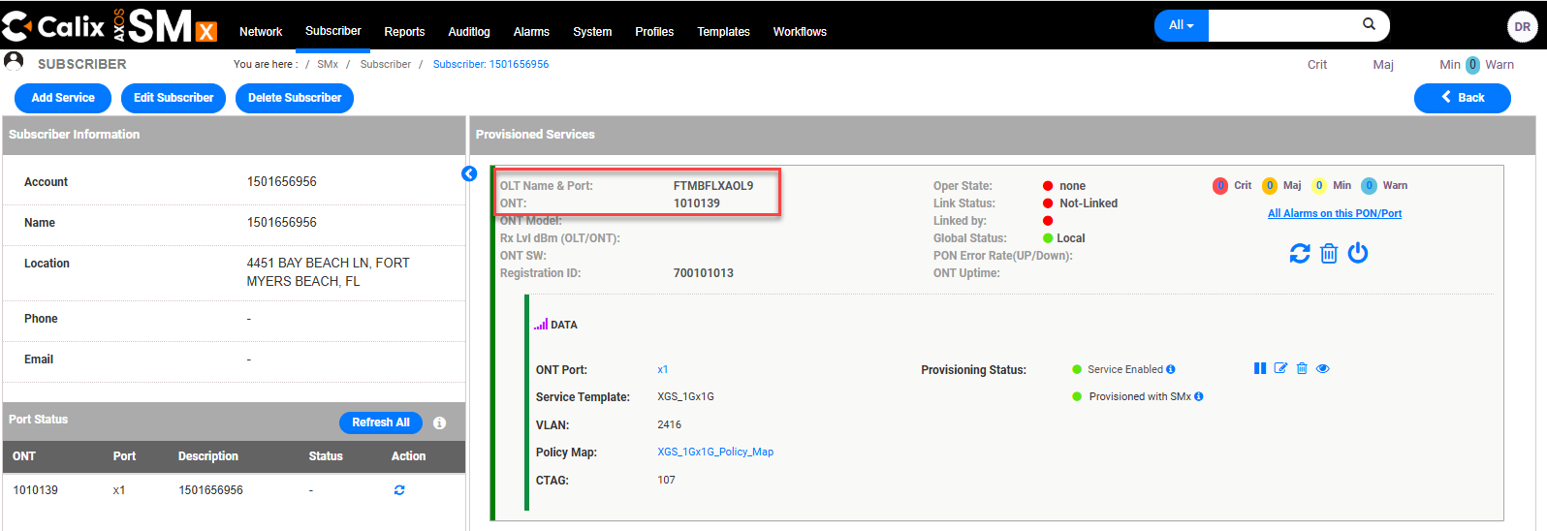
 | Select Network.
- Populate the OLT Name and Port information in the Name search box and wait for the results to narrow.
- Select the corresponding OLT Name and Port.
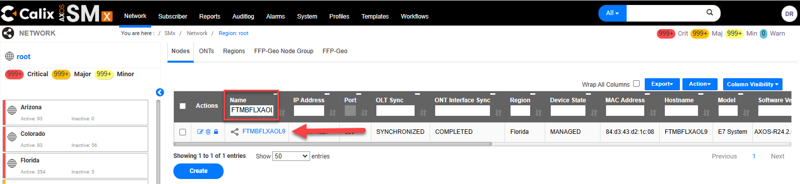
Select ONT.
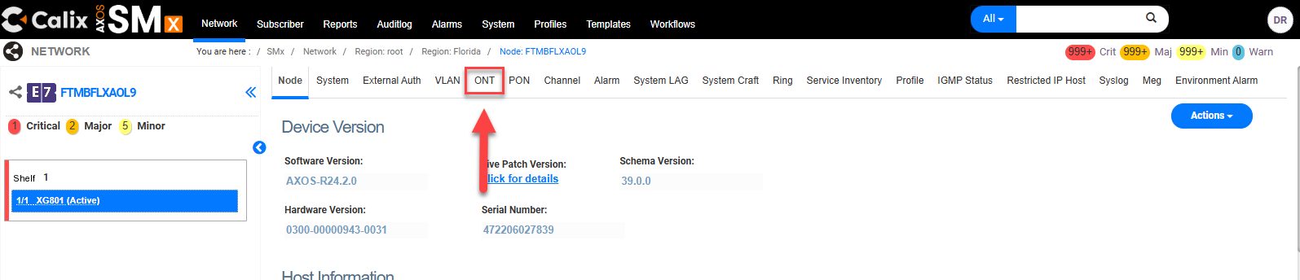
Populate the previously noted ONT number in the ONT ID search box and wait for the results to narrow.
Select the corresponding ONT.
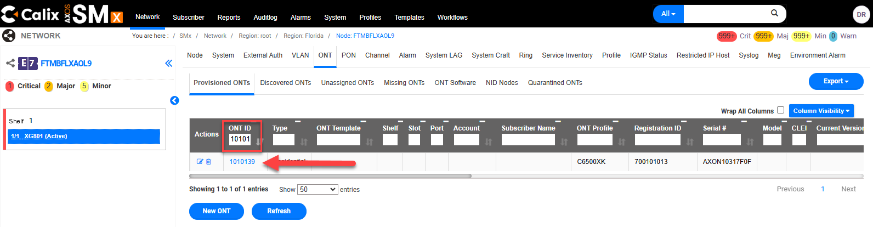
Select the Actions button to open the drop-down menu.

Select Edit ONT.

In the Registration ID field, input the Registration ID/aka RONTA {ex: REG ID (700 + RONTA)}
Also populate or correct any other missing or incorrect information such as:
- Subscriber ID
- Verify Shutdown is set to False (in the Advanced panel)



Select Submit.

 | An Update ONT successfully message will appear if successful.

Calix SMx Global SmartNID Search
Step | Action
How to perform a global search using the SmartNID Serial Number.
- Using the search bar, input either the CLLI or the IP of the device.

- Make sure the Node is Synchronized.
Note: If it isn’t, follow the How to Resynchronize the CLLI steps in this document.

- Select the OLT Name.

- Select the ONT tab.
- Populate the ONT ID in the ONT ID field.

- Select the ONT ID link.

- Select Actions to open the drop-down menu.
- Select Edit ONT.

- Remove ONT Serial Number
- Select Submit.
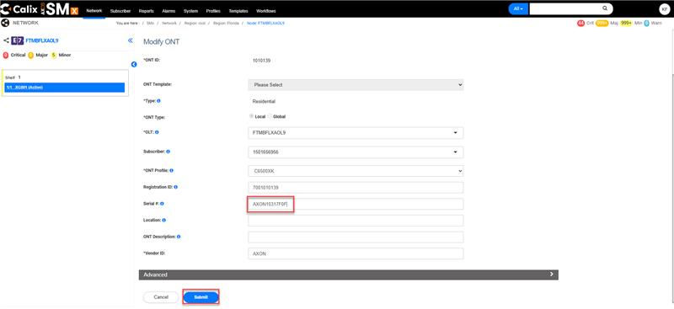
- Select Unassigned ONT’s tab.
- If the ONT Serial Number is displayed in the Unassigned ONT’s tab, it will display the OLT, shelf, and slot the ONT is physically connected to.
Note: compare the linked PON to the assigned facilities in Optius to determine if Technician is connected to the correct PON port (Splitter). If incorrect, the Technician will need to move the customer at the FDH to the assigned facilities.
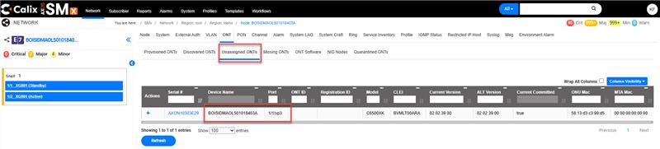
- Add Serial Number back to the ONT.
- Select Submit.

Document Management
Document Management
AUTHORS
Author | SME |  | Name |  |  |  | Telephone Number | E-mail Address
X |  |  | Debra Rudrud |  |  |  | 214-617-2123 | Debra.Rudrud@forgedfiber37.com
 | X |  | Kyle Field |  |  |  |  | Kyle.Field@forgedfiber37.com
 | X |  | Kimberly Evans
REVISIONS
Date |  | Issue |  | Revised By |  | Comments
12/08/21 |  | 1 |  | Angela Cox |  | Initial Version
06/26/22 |  | 2 |  | Jackie Stecher |  | Reviewed for Certification
06/06/23 |  | 3 |  | Debra Rudrud |  | Added section Linking an ONT.  Changed document Author from Angela Cox to Debra Rudrud
08/21/23 |  | 4 |  | Debra Rudrud |  | Added section Verifying SHUTDOWN is set to False
03/01/24 |  | 5 |  | Debra Rudrud |  | Added section How to Resynchronize the CLLI
10/15/24 |  | 6 |  | Debra Rudrud |  | Updated the DHCP Lease section.
10/29/24 |  | 7 |  | Debra Rudrud |  | Added the Related Documents section as it was missing. Added the new link to SMx effective 10/31/24
11/06/24 |  | 8 |  | Yolanda Garner |  | Update the Login section with the new SMx URL located in the Related Documents section, effective 11/07/24, and add extra verbiage.
12/11/24 |  | 9 |  | Debra Rudrud |  | Added the No Authentication/No Ping and When the Registration ID (aka RONTA) is missing, and Interface sections.  Added videos and added related links in the Related Documents section.  Updated the Create Subscriber section with new tips and notes and screen grabs.  The SMx Interface has changed. Updated images and language affected by this change.  Added the Resume Service section.  Re-titled DHCP Lease (Customer) to How to Verify the Subscribers IP Address  Added the link to the Reporting DSL Outages to Local DSL NOC (All Markets) process.
04/08/25 |  | 10 |  | Debra Rudrud |  | In the Link/Swap ONT section, added information that the preferred action is for the Tech to scan the replacement SmartNID ONT, as well as identifying that deleting the existing serial number may be referred to as dumying out the ONT.
05/09/25 |  | 11 |  | Debra Rudrud |  | The traditional way to View Service is broken with no ETR. Added the steps for the temporary process to View Subscriber.
05/15/25 |  | 12 |  | Debra Rudrud |  | Updated section names for View Service section.
06/30/25 |  | 13 |  | Joela Flaxa |  | Added section for Global Search
11/05/25 |  | 14 |  | Joela Flaxa |  | Update title to remove COR-TSC.
11/17/25 |  | 15 |  | Debra Rudrud |  | Updated the URL Links for NetworkCo Split. Lumen has it’s own SMx and NetworkCo SMx.
02/24/26 |  | 16 |  | Debra Rudrud |  | Added the Firmware section.
APPROVAL
Name |  |  |  |  | Title |  |  |  | Date Approved
Liz Bordano |  |  |  |  | Manager – Mass Markets Ops Excellence |  |  |  | 06/26/2022

